Adolescents’ favourite places: Re-defining the Boundaries between Private and Public Space.

Joan Abbott-Chapman*
University of Tasmania
Email: J.AbbottChapman@utas.edu.au

Margaret Robertson
La Trobe University
Email: m.robertson@latrobe.edu.au

Photographs by Barry Chapman

*Contact person Prof. Joan Abbott-Chapman
Faculty of Education
University of Tasmania
Private Bag 66, Hobart
Tasmania 7001, Australia
Email: J.AbbottChapman@utas.edu.au

Article published in the journal:
Space and Culture (2009) 12 (4) Nov., pp. 419- 434

Acknowledgement:
This research was funded by the Australian Research Council through the Institutional Research Grants Scheme.

Adolescents’ favourite places:
Re-defining the boundaries between Private and Public space.

Abstract:
This paper examines favourite places of samples of adolescents living in the island state of Tasmania, Australia. Results from four separate but related studies are presented which relate the discursive geographies of youth to their leisure pursuits. Young people’s reasons for choosing places which make them feel good, and the sorts of leisure activities which they enjoy there, are examined, in relation to theories of space as a cultural construct and international studies of place attachment and place experience. The analysis combines ethnographic and quantitative methods to explore the meanings of private and public space for youth. Goffman’s concepts of frontstage and backstage regions are used to explain the relationship between adolescents’ use of inside and outside space. Findings suggest that adolescent preferences for home, own bedroom and places in the natural environment express ways of re-defining the boundaries of private space as the practical embodiment of intergenerational power relationships.
(150 words)

Key Words: Adolescents, Favourite Places, Activities, Relationships, Sensations, Privacy.

Adolescents’ use of space: issues arising from the literature.
In examining adolescents’ favourite places, and the reasons they give for their preferences, this paper explores perceived boundaries between valued private and public places as ‘inside’ and ‘outside’ space. Until fairly recently children’s and adolescents’ favourite or ‘special’ places have received little research attention and have featured mainly in publications which help teachers and parents to ‘teach’ children about the natural environment (Kriesberg, 1999). Discursive constructions of the environment in children’s writing and artwork reveal children’s understanding of the natural environment in which “recreation discourses” far outweigh those connected with “tourism discourses” – the former being associated with places “away”, peaceful, beautiful, a refuge providing fun and rest (Cormack, Green & Reid, 2008, pp. 64-65). This supports Kriesberg’s argument that children’s special places, whether in the back yard, the local park or somewhere in nature are private places of relaxation and imagination, which “provide independence and foster exploring” (1999, p. 12). They are also cultural constructs which may change over time as children grow up. For adults as well as children favourite places are idealised constructs of places enjoyed and remembered which assist in regulating negative feelings and coping with perceived stress, whose emotional benefits are enjoyed irrespective of the frequency of visits (Korpela & Ylen, 2007). The exploration of the location and meaning of adolescents’ favourite places allows us to examine these aspects of culture and change in perceptions of space and place.

The actor’s subjective perceptions and meanings of physical space are in constant interaction and re-formation because space, like time, is culturally defined, with perceptual and physical boundaries which are dynamically related to action (Hall, 1969, p.115). This “hidden dimension” in private and public interactions is part of the “vocabulary of culture” which differs between different groups, communities, societies and generations (Hall, 1969). Lefebvre (1991) argued that since space is culturally produced and reproduced by human activity and association it is a site of struggle and contested meanings, which are created not only by sight but by smell and other senses, although the visual sense is dominant (Lefebvre, 1991, p.76). To this is added a rich overlay of memories of places and activities, contributing to visual accounts of place as text carried by individuals into new situations (Jardim Raynaud, 2004). “Put positively, place is space filled by people, practices, objects and representations”(Gieryn, 2000, p.465), and places are “interpreted, narrated, perceived, felt, understood and imagined”, so that meanings are not only experienced, they are learned through personal discovery.

For young people, experimentation, play and leisure activity are part of the process of discovery, socialization and the expression of emerging identity (Kleiber, 1999) in which “play and learning are intimately intertwined” (Hall, 1959, p. 56). Learning of place, response to place and emplacement of social relationships all have to be learned, through spoken language appropriate to a particular time, place, audience and culture, body language, facial expressions and physical gestures. These may need to be rehearsed in private within a restricted circle of close associates until perfected, in order for the actor to avoid embarrassment and disorientation, and censure on the part of the wider ‘audience’. Adolescents are particularly sensitive to this as “Identity vulnerability underlies much of the psychological experimentation of youth” (Crawford & Rossiter, 2006, p.133) and for young people “Peers are the measuring stick of how successful an experimental identity has been” (Bahr & Pendergast, 2007, p.159). The ‘joking relationship’ expressed in the ‘mucking around’ or ‘hanging out’ of adolescents in their private leisure spaces may be used in certain circumstances to deflect peer criticism and neutralize potential hostility (Hall, 1959, p.56).

In a fast changing, globalised world, the kaleidoscope of sensual impressions and social experimentation involved in growing up are shaped by the breadth or narrowness of places as cultural phenomena. These are learnt and ‘read’ by children and young people as part of daily experience and childhood memories of special locations are imbued with environmental and spatial knowledge (Robertson, 2000; Spencer, 1995). Memories of places and place activities introduce a dynamic temporal dimension which is linked to the individual’s own maturation and widening experience. Matless (1998) traces the elements of childhood, place affiliation and connectedness with a landscape aesthetic that endures throughout life. There is a sense of belonging of the body that is ‘of space’ (Massey 2005) and deeply subjective (Biehl, Good & Kleinman, 2007). This is true of both inside and outside spaces, since the characteristics of home, the home’s surroundings and the local neighbourhood are all important sites of childhood and adolescent activities and sources of feelings of belonging (Abbott-Chapman & Robertson, 1999).

The private spaces of the home, and the importance of ‘my bedroom’ as a place of seclusion, familiarity, security and expression of identity, contextualize many leisure activities, passive and active, in which adolescents are involved. Gender differences in place preferences have been noted by a number of researchers – females more often choosing private indoor places in and around the home, while males choose outdoor and public spaces especially sports facilities (Abbott-Chapman & Robertson, 1999; James 2001). The presence or absence of cultural artifacts in the home, such as books, works of art, computers, music systems and mobile phones are part of the developmental play and learning space and the “environmental affordances” (Gibson, 1979) from which socio-spatial learning is gained. Nowadays, young people’s access to a home computer which may be located in their bedroom (ostensibly for homework) links home-space to cyberspace, making distinctions between ‘inside’ and ‘outside’, private and public space appear redundant, or at least fluid. In 2006/7, 73 per cent of Australian homes had access to a home computer and 64 per cent of homes had Internet access (ABS, 2007). For those who have ready access to Information Communication Technology (ICT) “No longer are people constrained by enclosures such as distance and time” and it is possible to be “almost anywhere within cyberspace” (Bahr & Pendergast, 2007, p.29).

However, the richness or poverty of environmental affordance to which young people are exposed both inside and outside the home is only part of the equation- the degree of access and engagement is also important (Chawla, 2002; Chawla & Heft, 2001). This is particularly true in urban environments in which physical and social barriers may impede access, and so limit exploration and discovery. In past times, when security issues and terrorist threats were not the dominant issues they are today, children were much freer to ‘play outside’ and roam the streets or countryside with relatively little adult interference or supervision. A British study showed “that the radius within which children roam freely around their homes has shrunk by almost 90 per cent since the 1970s” (James, 2007, p.36). By contrast a writer describing childhood memories of the 1940s and 1950s in Britain, reports that “the thing I remember with most gratitude was being able to do things alone. It was perfectly safe to do so then, and we took it for granted – roaming around the village and the common”. The writer remembers a sense of “freedom and simultaneous security” (Smith, 1999, p.195). In those days, the term ‘outside’ encompassed streetscapes in the city and landscapes in the country which provided opportunities for discovery and growth to a greater extent than appears today.

Malone points out that urban public space is contested within “geographies of power”, in which youth values and culture are seen as a problem that has to be regulated (2002, p. 158). For some youth groups ‘hanging out’ in urban and suburban shopping malls has replaced outside street play, but Malone suggests that public spaces in cities become defined as “adult space” and that “young people begin to occupy the fringes of the neighbourhood” (Malone, 1999, p. 22). She distinguishes “open space” in which diversity is accepted, and in which young people may feel comfortable, and “enclosed space” in which conformity is regulated in ways which may make young people feel “out of place”. The suspicion faced by groups or ‘gangs’ of youth in urban spaces is accentuated by the widespread use in city centres of surveillance cameras designed to deter or detect criminal activity. Changes in social and political climate, behaviour regulation and policing, help mould young people’s subjective geographies and the interpretations of space available to them.

Young people’s access to recreational open space in the natural environment is therefore important in encouraging a sense of freedom, and the development of subjective geographies through the physicality of playing, exploring, living and learning (Holloway & Valentine, 2000; Robertson et al., 2001). Baker (2002) has drawn attention to the ways in which the “discursive geographies” of parks as well as natural landscapes may be read, produced and consumed through the material (ecological), discursive (text) and touristic (experience). The idealization, even romanticisation, of nature has increased over time among urban populations suffering over-crowding and pollution. The search for the mythical ‘Shangri-la’, reflecting ways in which conceptions of nature are invented and reinvented, has “culminated in contemporary environmentalism” (Macnaghton & Urry, 1998, p. 32). However, the diversity of responses triggered by nature should not be underestimated, since responses to nature rely on “inter-subjectively shared meanings” reflecting cultural understandings established over time (Kaivola & Rikkinen, 2004, p. 122). These create landscapes of the mind, or mindscapes, which ally memories and emotions, imagination and dreams, encapsulating remembered pleasurable and lasting experiences. For Finnish adolescents “Nature with its lakes and woods, is not hostile but a safe environment in which one can relax and feel solitude and timelessness” (p. 123).

However, in highly urbanized Singapore Kong, Yuen, Sodhi and Briffett found that “young Singaporeans interviewed have little interest in and affinity for nature” (1999, p. 12). The authors attribute responses to limited opportunities for contact with nature to over-protectiveness of parents who worry about the dangers of play in natural areas, and “the abundance of other recreational and entertainment options” in an urban setting. This causes youth to privilege urban development over nature conservation. Such research reveals that concepts of nature and special places in nature are not a given, they have to be learned and experienced, along with the “multiplicity of meanings invested in nature which are socially constructed and reflect changing values inherent in society” (Kong et. al., 1999, p. 4). In Hong Kong, research revealed that students’ favourite places included their own homes, urban parks and gardens designed to mirror nature. These places “made them feel comfortable, relaxed as well as happy, safe and free” (Lee 2004, pp.149).

The notions of freedom and relaxation are a recurrent theme in studies of young people’s responses to leisure spaces. But cultural understandings of ‘free time’ and ‘free space’ are rapidly changing. For use of ICT creates new subjectivities as interactive tools Web 2.0, Web 3.0 and now Web 4.0 enable users to explore ideas and test theories of self in constantly changing spaces (Keen, 2007). These help to increase “confusion and incoherence in our sense of space and time, in our maps of places where we live, and in our ideas about the times in terms of which we organize our lives” – confusions and distortions which are expressed in postmodern pop culture (Strinati, 1995, p. 226). Massey argues we need to imagine globalised “space as always in process, as never a closed system” or a zone of “related specificity” (Massey 200, p.15).

Linking the literature with our research
While breaking boundaries between local and global and notions of fluid space may seem liberating, international research suggests that young citizens of the global economy still retain their local cultural, even tribal, viewpoints and identities, managing the relationship between the “local me” and the “global me” through negotiating new socio-spatial boundaries (Zachary, 2000). The exploration of adolescents’ perceptions of favourite places is a way into these changing cultural constructs and spatial literacies of private and public spaces. In this regard, the ethnographic writings of Goffman (1971) have provided valuable insights. Goffman used a dramaturgical metaphor to analyse the “front and backstage regions” of everyday life in which we play our roles. This allows the creation of a facade (both physical and social) for presentation of self in a more orderly and structured way than the haphazard and sometimes chaotic backstage regions will allow. He argued that in learning to play multiple social roles individuals use space in different ways to rehearse, manage and protect the integrity of their role performances. This involves different types and degrees of ‘audience’ control and segregation. At home this might mean the difference between the kitchen or bedroom and the sitting room where guests are entertained; in business the difference between the staff tea room and the Directors’ Board Room. But as Goffman and later writers have recognized, the definition of ‘interior’ and ‘exterior’ locations and places are not constrained by built architectural forms and conditions (McCarthy, 2005). For Goffman, a “region” is any place that is “bounded to some degree by barriers to perception” (Goffman, 1971, p. 92). The actor is in control of the performance, not the space, and so may shift perceptual boundaries of the front or back region by changing the visual ‘props’ such as dress, manner, furniture or equipment. In this sense space is fluid. More recently, Massey (2005) captures some of the spirit of this thinking with the phrase “for space”.

Goffman’s concept of “outside” space, which he calls a “third” or “residual” region, is less developed. This concept describes outside space in town or country “that is neither front nor back with respect to a particular performance” (Goffman, 1971, p. 117). An individual or group of individuals in a “team performance” may define an “outside” region as “backstage” or private by ensuring audience segregation through front region control, so that unwanted audiences do not view the performance (Goffman, 1971, p.81). An example would be a group of adolescents at the beach who do not want their parents to see them drinking alcohol, and so use outside space as private space. Such shifting of perceptual boundaries and associated normative expectations of private and public space provide the focus for our research into adolescents’ favourite places.

Research Methodology
The research setting
Tasmania is a sparsely populated, largely rural, island state of Australia with a land area similar in size to Scotland and around half a million inhabitants. Only 41% live in the capital city, Hobart, which is the lowest proportion of all the states. Apart from inhabitants of the second largest city, Launceston, the rest of the population, live in medium to small towns or rural and remote areas (BRS 2008). The population is the most homogeneously Anglo-Celtic in Australia with only 11 per cent of the population born overseas compared with 23 per cent in Australia as a whole. Aboriginal and Torres Strait Islanders comprise 3.5 per cent of the population (ABS 2004). The state ranks lowest on a number of socio-economic indicators (ABS 2004). The climate is temperate and the outstandingly beautiful landscape is mountainous, with areas of wilderness and large national parks, spectacular coast line and pristine beaches.

Background to the research
The four research surveys from which findings are drawn were conducted in Tasmania between 1999 and 2001 among adolescent secondary students in both government and non-government schools. The surveys were conducted for different purposes relating to young people’s use of space for leisure activities (Abbott-Chapman & Robertson, 2001; Robertson & Abbott-Chapman, 2004), and factors which influence adolescents’ perceptions of risk and risk activities (Abbott-Chapman & Denholm, 2001; Abbott-Chapman, Denholm & Wyld, 2008). Although diverse in design and intent, all contained questions asking secondary school students to name their favourite place and to give reasons for their choice. Comparative findings from these surveys on adolescents’ favourite places were brought together for the first time in an unpublished paper for a conference on ‘senses of place’ (Abbott-Chapman & Robertson, 2006). This article is a completely revised and expanded version of that conference paper.

Research methods
A constructivist standpoint underpins the research. Grounded in the disciplines of sociology, geography and psychology it explores adolescents’ subjective meanings of favourite place using both qualitative and quantitative methods. Methods used in the original surveys included one-to-one interviews using photographs of places and leisure activities as triggers for responses, focus groups and questionnaire surveys. Findings discussed are derived from qualitative analysis of open ended questions in interviews with Year 9 students (73 respondents) and in a questionnaire survey of Year 9 and 10 students (356 respondents) with respect to the two ‘place’ surveys; and statistical analysis of closed choice questions, using categories generated by the earlier research, in questionnaire surveys of Year 10 students (127 respondents) and Year 11 and 12 students (954 respondents) with respect to the two ‘risk-taking’ surveys. In order to explore the subtext as well as text of reasons given, re-analysis of the qualitative data from the first two surveys was undertaken, using “theoretical thematic” coding to give the “analytic story” greater “coherence” (Charmaz, 2006, p.63). Where some qualitative responses had been previously unassigned to categories because responses were ‘mixed’ the predominant response was chosen and the answer re-assigned. Where ‘interstate’ choices related to the home of a separated parent or the homes of other close relatives these responses were re-assigned to ‘home’. The quantitative data from the second two surveys were also re-analysed using the SPSS statistical package. All respondents to the ‘favourite place’ question were included – that is 68, 287, 126 and 929 students in Years 9, 10, 11 and 12 or 1,410 students in all. The quantitative and qualitative analyses are used in complementary ways to map out and explore in-depth the properties and meanings of favourite places.

Sample characteristics
In each of the four studies the gender distribution of each sample was almost balanced. The youngest students were aged 14 and the oldest 19, but the majority of respondents were aged between 15 and 18 years. Among Year 9 and 10 students 70.2% lived in towns and 29.5% in rural areas. Among Year 11 and 12 students 75.5% lived in towns, and 24.5% in rural areas. These distributions are representative of the Tasmanian population. Participants attended both government and non-government schools and represent a wide cross-section of Tasmanian youth in terms of socio-economic background. However, the location of the schools and secondary colleges attended differed in that the surveys of the Year 9 and 10 students, both qualitative and quantitative, took place in different regions of the state, while the surveys of Year 11 and 12 students took place in Hobart, the capital city. After Year 10, students must complete Years 11 and 12 in a senior secondary college or a non-government school - the majority of which are located in the cities of Hobart and Launceston. The location of the school or college may have affected place responses in ways which cannot be measured in this research.

Limitations of the analysis.
Findings presented here are suggestive rather than conclusive and raise questions which could only be answered by repeating and updating the research on favourite place with comparative samples in other Australian states, including more urbanized populations. Inclusion of questions on ethnicity and aboriginality, which were not included in these surveys, would provide added insights. The role of ‘cyberspace’ in relation to adolescent perceptions of the boundaries between public and private space, which was not explicitly covered in the surveys discussed, would usefully be included in further studies.

Summary of findings on adolescents’ favourite places.
Favourite places
The favourite places named by respondents in the four surveys are shown in Table 1. This reveals that the student’s own home, the student’s own bedroom, or a close relative’s home, are the most cited favourite places. These are closely followed by places in nature, such as at the beach, by the river and in the country (or ‘bush’ in Australia). Places and facilities in town or city, such as cinemas, shops, sports centres and swimming pools, are cited only by a minority. Only one person cited ‘school in town’ as the favourite place because it was a place at which to be with friends. Although crowds, loud music and entertainment venues are popular with many young people these did not feature largely in their choices of favourite place.
Table 1: Adolescents’ Favourite Places
Adolescents’ Favourite Place | Year 9/10  (Qual.) | % | Year 10  (Quant.) | % | Year 11/12  (Quant.) | %
Home; Rel’s home | 64 | 18.0 | 25 | 19.8 | 117 | 12.6
Own bedroom | 32 | 9.0 | 32 | 25.4 | 185 | 19.9
Friends’ place | 41 | 11.5 | 17 | 13.5 | 285 | 30.7
Place in Nature | 112 | 31.5 | 32 | 25.4 | 224 | 24.1
Place in Town | 62 | 17.5 | 16 | 12.7 | 80 | 8.6
Interstate/overseas | 44 | 12.5 | 4 | 3.2 | 38 | 4.1
Total | 355 | 100.0 | 126 | 100.0 | 929 | 100.0

It should be noted that the category ‘home’ covers spaces in and around the home or relative’s home, including the garden where pets may be kept or games played. For those living in the country this might include land such as ‘the pony paddock’. Similarly ‘friend’s place’ is the phrase used by adolescents to describe the friend’s home and its surrounds, and in a small minority of cases the immediate neighbourhood. The definition of ‘place’ is thus somewhat elastic. ‘My own bedroom’ was not mentioned as often by the Year 9 and 10 students, in response to an open-ended question, as by the Year 10 and Year 11/12 students, in response to the closed-choice question. There may be reasons other than the methodological difference for the lower response. Younger students, especially from less affluent families in rural and regional areas may not have their own bedroom and have to share with siblings. Usually in homes where space is at a premium it is older children who gain a room of their own. Older students more often cited their friend’s place as their favourite and this included the boyfriend’s or girlfriend’s home.

The larger proportion of younger students who chose town places suggested that they may not have begun to experience feelings of city exclusion that Malone (2002) describes as being experienced by older adolescents and young adults. The younger students also cited more often than the older students favourite holiday places interstate and overseas. Queensland for example was chosen for its climate, theme parks and beaches, illustrating the memory overlay discussed in the literature.
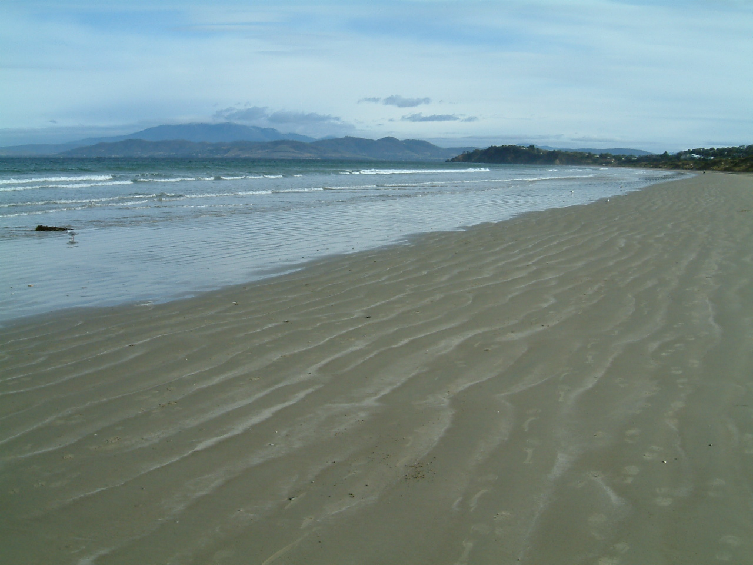

Figure 1: At the beach – Carlton Beach, Tasmania

A substantial proportion of students in each sample (between 24 per cent and 31 per cent) said that their favourite place is in the natural environment – in the country, by the river or at the beach. The beach was especially popular (Figure 1). Lefebvre has noted the freedom and enjoyment associated with beaches, as unstructured spaces in which issues of subjectivity and objectivity dissolve and the body behaves as a ‘total body’ (Lefebvre 1991, p.384).

Gender and rural/urban differences
Significant gender differences in favourite places were found in all four samples. Figures 2 and 3 compare separate findings from the Year 10 and Year 11/12 quantitative surveys. Girls chose their own bedroom to a far greater extent than did boys. For both student groups there was a highly significant χ² probability level - 0.8% (Year 10) and 1% (Years 11/12). These findings confirm those from other surveys discussed in the introduction.
Figure 2: Year 10 students’ favourite place by gender

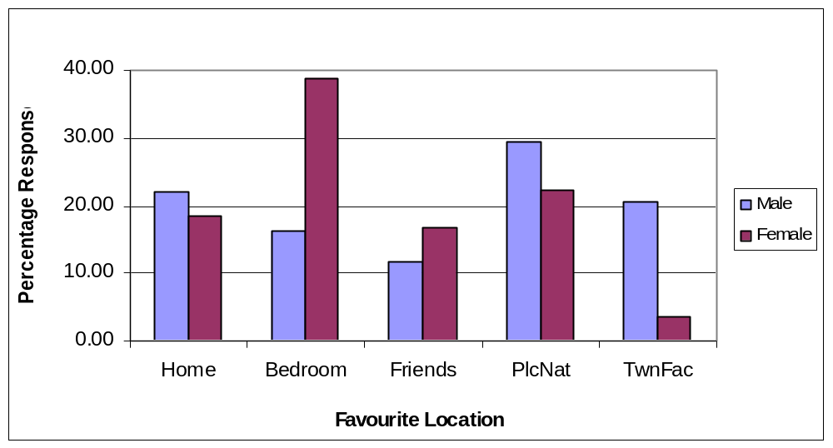
Among the older students places in nature were chosen by more females than males and town facilities were chosen by more males than females. As young people grow to maturity and become more independent, both males and females are less likely to focus their activities and preferences on the home and to look outwards – especially to local social sites where they can be with friends.
Figure 3: Year 11/12 students’ favourite place by gender

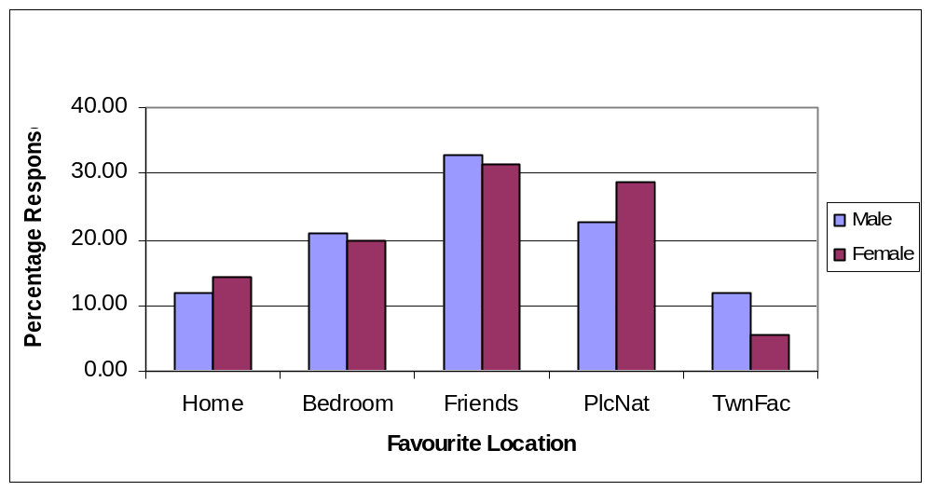

To test the assumption that place attachment is learned and familiarity with and enjoyment of places in nature is likely to predispose the individual to choose a favourite place in the natural environment, the home residence of the Year 10 and Year 11/12 students were correlated with favourite places (Figures 4 and 5)..

Among the younger Year 10 students there is no significant correlation (χ² probability level 15%) between place of residence and favourite place, although numbers are small. Among Yr11/12 students there is a highly significant correlation (χ² probability level 0.05%) with more country students choosing places in nature while urban dwellers choose places in town. This suggests that attending a senior secondary college in a city does not in itself change the place learning and place preference of country students. Among both age groups town dwellers more often chose ‘my bedroom’ as their favourite place.
Figure 4: Year 10 students’ favourite place by rural or urban residence

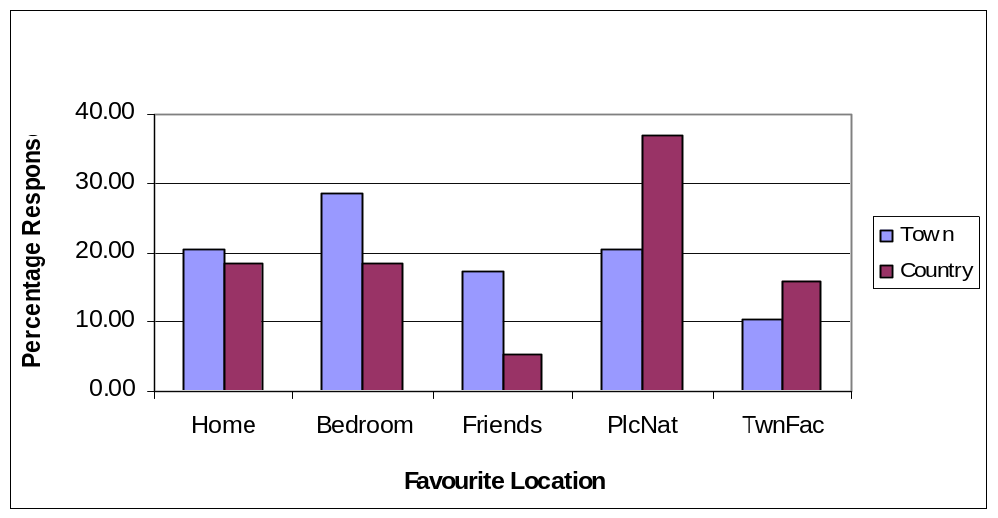

Other statistical analysis of responses regarding location of friends has shown that when most of the students’ friends live locally, whether in a country or local neighbourhood, the favourite place for meeting friends tends to be local, while for those who have few local friends the favourite place for meeting friends tends to be in the town centre.

Figure 5: Year 11/12 students’ favourite place by rural or urban residence

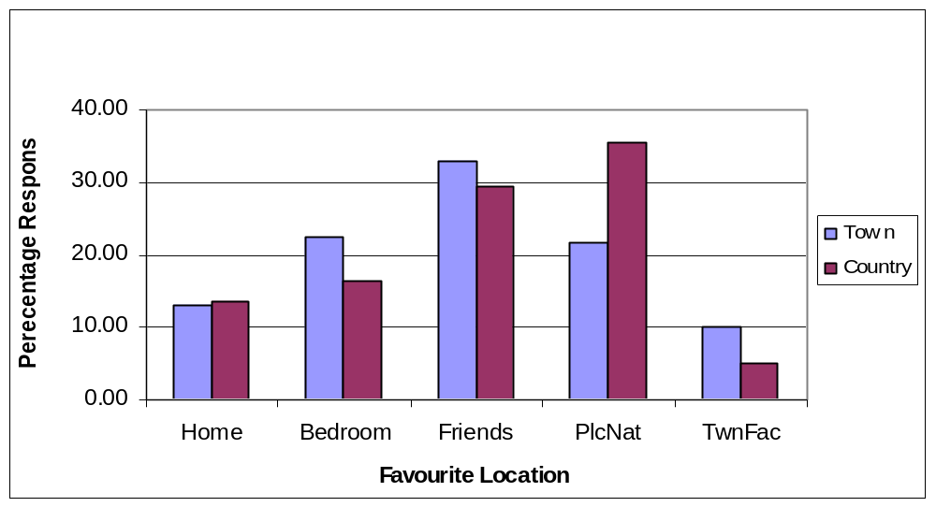

Taking ‘time out’ in the favourite place – private spaces at home and in nature

Previous qualitative surveys had suggested that the choice of favourite place is related to the adolescents’ need to withdraw to a private place apart from adult surveillance and control – what Goffman (1971) called a “backstage region”. This accords with writings on younger children’s special places as private places of discovery “away” from adults (Kriesberg, 1999). In the subsequent quantitative surveys of Year 10 and Year 11/12 students, respondents were asked whether they felt the need to ‘take time out’ from people and things which bothered them. In interviews this was shown to include parents and siblings when there were family rows. In interviews and focus groups adolescents also used phrases such as ‘veg out’ and ‘chill out’, to emphasise the need to relax, ‘go with the flow’ and escape pressure and stress at home and at school.

Table 2 shows that those wanting constantly or ‘always’ to take time out were more likely to choose their own bedroom or a place in nature as their favourite place, while those who only wanted to take time out ‘sometimes’ were more likely to choose places in the local town or friends’ places. If the cross tabulation is confined to the categories Always (A) and Sometimes (S) there is a χ² probability level of 0.01%. Examination of the Always/Sometimes odds reveals more - in ascending order of Odds Ratio.
Favourite place A/S Odds Normalised Odds
Friend’s place 0.304 0.63
Place in town 0.385 0.80
Home/relative’s home 0.5 1.04
Places in Nature 0.574 1.19
Own Bedroom 0.745 1.55
Total 0.481

Table 2: Taking ‘time out’ correlated with favourite place (Year 11/12 students)
(N= 891)
Favourite Place | Time Out No/Don’t Know | % | Time Out Sometime | % | Time Out  Always | % | Total | %
Home; Rel’s home | 9 | 17.0 | 72 | 12.7 | 36 | 13.2 | 117 | 13.1
Own bedroom | 7 | 13.2 | 102 | 18.0 | 76 | 27.9 | 185 | 20.8
Friends’ place | 19 | 35.8 | 204 | 36.0 | 62 | 22.8 | 285 | 32.0
Place in Nature | 10 | 18.9 | 136 | 24.0 | 78 | 28.7 | 224 | 25.1
Place in Town | 8 | 15.1 | 52 | 9.2 | 20 | 7.4 | 80 | 9.0
Total | 53 | 100.0 | 566 | 99.9 | 272 | 100.0 | 891 | 100.0

The student’s own bedroom attracted the greater proportion of ‘Yes always’ responses, followed by ‘places in nature’ and places in ‘own or relative’s home’ (three students said the toilet was the only place to get some privacy!); whilst friends’ places attracted the smallest proportion followed closely by ‘places in town’. This suggests that places at home and in nature shared similar withdrawal or privacy features where ‘audiences’ are restricted and social distance is maintained. Although bedroom is an ‘inside’ space and bush or country an ‘outside’ space, personal and private space is more easily managed there than in the commercial and public places of the town or in the domestic spaces of friends’ places.

Reasons for choosing a favourite place – activities, relationships and sensations.

In seeking to explain these choices we have re-examined in depth the reasons given by the Year 9 and 10 students as to why they chose their favourite place. Although asked to name one favourite place a number of students named two or three places, so in this latest phase of the re-analysis we identified and categorized every mention of favourite places of the 355 respondents rather than the place which was of ‘primary’ or ‘main’ significance. The reasons were coded according to associated activities, relationships and sensations (Table 3). Interstate and Overseas places have been omitted.

Table 3: Reasons for choice of favourite places - qualitative descriptors.
(Year 9/10 students’ responses to open ended question)
Descriptors of favourite place  From students’ responses | Home % | Nature  % | Friends  % | Town  % | Total  %
Activities involved (named) | 21.8 | 32.4 | 25.7 | 56.2 | 32.3
Fun, lots of things to do | 4.5 | 7.4 | 19.2 | 16.3 | 10.3
Social relationships –fam.,frnds | 14.3 | 10.8 | 43.6 | 21.3 | 19.6
Relaxing, carefree, freedom | 11.3 | 12.8 | 6.4 | 6.2 | 10.0
Peace ,quiet, sense of space | 15.0 | 29.7 | 5.1 | 0.0 | 15.5
Privacy, seclusion, own space | 15.0 | 6.8 | 0.0 | 0.0 | 6.8
Familiar, comfort, own things | 18.1 | 0.0 | 0.0 | 0.0 | 5.5
Total percent | 100.0 | 100.0 | 100.0 | 100.0 | 100.0
Total number of mentions | 133 | 148 | 78 | 80 | 439

Among these adolescents the most often-cited reasons for choice of favourite place describe activities associated with the chosen place (32%). To these are added replies such as ‘fun, lots of things to do’ covering unspecified activities (10%) – making 42% in all. Social activities were most associated with town places, in public places such as shops, cinemas and sports centres (73%), and friend’s place including indoor and outdoor activities (45%).Typical comments were: ‘I love to go shopping and meet all my friends’, ‘At my friend’s house there’s heaps more things to do like horse riding and swimming’. ‘Friend’s place –play computer and sports’. Favourite places in the bush, at the beach and by the river were associated with both solitary and group activities including: walking, bike riding, motorbike riding, horse riding, camping, sailing, fishing, surfing, swimming, waterskiing and body boarding. Indoor activities in the home were mainly sedentary pursuits such as watching TV, videos, using a computer and playing music or musical instruments. Relationships with friends, and activities enjoyed with them, featured most with respect to ‘friends’ place’ and ‘town’ places. ‘In town I see my friends from other schools’. Friends were mentioned more than family members.
By contrast, the reasons for choosing home places or places in nature concentrated more upon the sensations enjoyed rather than activities or relationships associated. Places at ‘home’ or in ‘nature’ were often described as conveying a sense of peace, quiet and space, relaxation and freedom, as well as privacy, seclusion and familiarity (Figure 6).

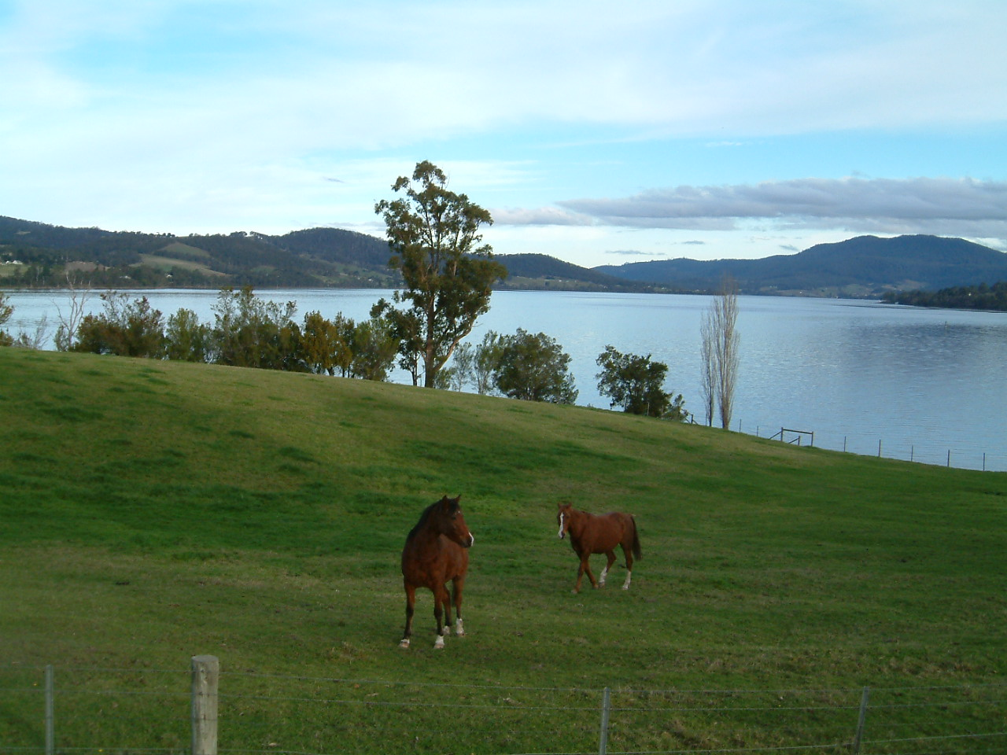

Figure 6: Bush/Nature – Castle Forbes Bay, Tasmania

Typical comments were: ‘My bedroom because it’s quiet and I can think’, ‘My bedroom is my own space- I can do what I like’, ‘The beach is quiet and worry free’, ‘The bush is peaceful, not many people around’, ‘The beach/bush –lots of space and freedom’. These sorts of sensations, comprised 59% of descriptors of ‘home’ and 49% of ‘places in nature’ – compared with only 12% of descriptors of friend’s place and 6% of town places. Paradoxically, perceptions of privacy predominate in both the inside spaces of home and outside spaces of nature, despite the ‘public’ status of nature. The experiences and utilization of the four types of place are therefore different, and the boundaries of private and public space shift with associated activities, relationships and sensations.

Conclusions and Discussion of findings:

The analysis of adolescents’ choices of favourite places in the island state of Tasmania, and the reasons given for these choices has provided insights into adolescents’ use of private and public space for recreation. While ‘favourite place’ is not necessarily the most habituated space, it provides a way into understanding idealised spaces in usage and memory – spaces in which the respondent feels most pleasure and enjoyment. Findings reveal that local, familiar places in and around the home and in the natural environment are chosen as favourite places for ‘private’ adolescent activity, either solitary or with friends. Use of computers was a favourite occupation in some students’ bedrooms, linking for them spaces which are local and global, private and public, but this did not predominate in the answers to open ended questions. Further research is needed to ascertain the role of ‘cyberspace’ in choice of favourite place and the interaction of the local and global me (Zachary 2000).

Findings confirm the significant gender differences in use of indoor and outdoor spaces, with girls more than boys choosing the safety and security of home and own bedroom with the familiarity of their ‘own things’ around them. They also illustrate the space learning that takes place in childhood – with those who live in the country more often choosing ‘open’ country places while town dwellers more often choose ‘enclosed’ places in town. Where country dwellers seek privacy in nature, town dwellers seek privacy in ‘my bedroom’. The overall importance of places in nature may also reflect the environmental affordances provided to young people (Gibson, 1979) growing up in Tasmania. The fact that older adolescents more often chose favourite places as sites of social activity at friends’ places and in their local neighbourhood, rather than places in the centre of town, may relate to what Malone (1999) called the perceived geographies of exclusion of adolescents in city centres.

Most cited reasons for place preference, and demonstrated place attachment, are those which link leisure pursuits with chosen place and illustrate place discovery through the active life of adolescents. These pursuits are many and varied - more sedentary and solitary indoors and active and social outdoors. The peer group emerges as very important, as we would expect, as does the importance of activities and places shared with friends. However, associated sensations emerge as equally important as activities and relationships in defining what is favourite and special about place. Places in the home, especially own bedroom, and in nature are predominantly described as conveying ‘peace, quiet, sense of space, relaxation and seclusion’- what we have termed ‘private places of withdrawal’. Although initially unexpected, we suggest these reactions may result from the need of young people to escape daily pressures in our time/space compressed world, and to re-define for themselves the boundaries of ‘private’ space in which to reflect and make meaning. Supportive research findings on the expressed need of respondents for time out from people and things which bother them highlight their need to exercise what Goffman called “audience control” (1971, p.201).

Findings suggest that differences in adolescents’ perceptions and usage of private and public spaces, indoor and outdoor spaces, are multidimensional in ways which transcend the physical boundaries of space. Goffman’s (1971) concepts of front stage and backstage regions, and outside regions which may be either front or backstage regions, have assisted our analysis. Roles played in backstage regions are those which are protected by audience management and control, while roles played in frontstage regions are open to the appraisal and censure of adults and space contestation (Lefebvre 1991). The adolescents’ own bedroom, places in the home and in nature appear to share many features in common as backstage regions, in relation to adolescent activities enjoyed in relative privacy, along with sensations of seclusion. Friends’ places and places in town appear to be more activity focused, and are enjoyed in company with peer group friends. In many ways they are both public places and front-stage regions, but in Malone’s (2002) terms town is an “enclosed” space while friends’ places are “open”. This suggests that the dimensions of front/back, inside/outside and enclosed/open might all usefully be considered when defining the fluid boundaries of private and public spaces, as these describe interlocking properties of space which are perceptual, physical and normative. They also reflect intergenerational power relationships and represent Hall’s (1969) different vocabularies of culture.

References.
Abbott-Chapman, J. & Denholm, C. (2001). Adolescents’ risk activities and risk hierarchies and the influence of religiosity. Journal of Youth Studies, 4 (3), 279-298
Abbott-Chapman, J., Denholm, C. & Wyld, C. (2008). Combining measures of risk perceptions and risk activities: the development of the RAPRA and PRISC Indices. Risk Analysis- An International Journal, 4(3), 279-298
Abbott-Chapman, J. & Robertson, M (1999). Home as a private space: some adolescent constructs. Journal of Youth Studies, 2 (1), 23 -43.
Abbott-Chapman, J. & Robertson, M. (2001). Youth, leisure and home: space, place and identity. Society and Leisure, 24 (2), 485-506.
Abbott-Chapman, J. & Robertson, M. (2006). Places of the heart: a celebration of adolescents’ favourite places as identity space. Unpublished paper presented at Senses of Place International Conference, April 6th - 8th , University of Tasmania, Hobart.
ABS (2004). Australian Social Trends. (Catalogue no. 4102.0) Canberra: Australian Bureau of Statistics.
ABS (2007).Household use of Information Technology Australia 2006/7. (Catalogue no. 8146.0) Canberra: Australian Bureau of Statistics.
Bahr, N. & Pendergast, D. (2007). The Millenial Adolescent. Camberwell, Vic.: The Australian Council for Educational Research, Ltd.
Baker, J. (2002). Production and consumption of wilderness in Algonquin Park. Space and Culture, 5 (3), 198-210
Biehl, J., Good, B. & Kleinman, A. (Eds) (2007). Subjectivity: Ethnographic Investigations. Berkeley: University of California Press.
BRS (2008) Country Matters: Social Atlas of Rural and Regional Australia. Canberra: Bureau of Rural Sciences, Australian Government.
Chawla, L. (2002). Growing up in an urbanizing world. London, Paris: Earthscan Publications/UNESCO.
Chawla, L. & Heft, H. (2001). Children’s competence and the ecology of communities: A functional approach to the evaluation of participation. Journal of Environmental Psychology, 22, 201-216.
Cormack, P., Green, B. & Reid, J. (2008). Children’s understanding of place: Discursive constructions of the environment in children’s writing and artwork about the Murray-Darling Basin. In F.Vanclay, M. Higgins & A. Blackshaw (Eds) Making Sense of Place: exploring concepts and expressions of place through different senses and lenses. Canberra: National Museum of Australia, pp. 57-76
Crawford, M. & Rossiter, G. (2006). Reasons for Living. Hawthorn, Victoria: The Australian Council for Educational Research , Ltd.
Charmaz, K. (2006). Constrructing Grounded Theory: A Practical Guide Through. Qualitative Analysis. London, Thousand Oaks, New Delhi: Sage Publications.
Gibson, J.J. (1979). The Ecological Approach to Visual Perception. Boston: Houghton Mifflin.
Gieryn, T.F. (2000). A space for place in Sociology. Annual Review of Sociology, 26 (1), 463-506.
Goffman, E. (1971). The Presentation of Self in Everyday Life. London: Allen Lane, Penguin Press.
Hall, E.T. (1959). The silent language. New York : Premier Books.
Hall, E.T. (1969). The Hidden Dimension: an Anthropologist examines Humans' use of Space in Public and in Private. New York: Anchor Books, Doubleday.
Holloway, S. & Valentine, G. (Eds.) (2000). Children’s Geographies. London: Routledge.
James, K. (2001). "I just gotta have my own space!": The bedroom as a leisure site for adolescent girls. Journal of Leisure Research, 33, 71-90.
James, V. (2007). Lost in the concrete jungle. Geographical, 79, November, 34-38.
Jardim Reynaud, A.T. (2004). Migrants’ Accounts of Rio: The contribution of affect to remembering place. Space & Culture, 7 (1), 9-19
Kaivola, T. & Rikkinen, H. (2004). Recreation, free-time activities and space related experiences of Finnish young people, Chap. 11 in M. Robertson & M. Williams, (Eds.), Young People, Leisure and Place: Cross-cultural Perspectives. New York: Nova Science Publisher, Inc., pp.115-130
Keen, A. (2007). The Cult of the Amateur. Boston: Nicholas Brealey Publishing.
Kleiber, D. (1999). Leisure experience and human development. Boulder CO: Westview Press (Basic Books).
Kong, L., Yuan, B., Sodhi, N.S. & Briffett, C. (1999). The construction and experience of Nature: Perspectives of Urban Youth, Tijdschrift voor Economische en Sociale Geografie, 90 (1): 3-16.
Korpela, K. & Ylen, M. (2007). Perceived health is associated with visiting natural favourite places in the vicinity. Health and Place, 13 (1) March, 138-151
Kriesberg, D.A. (1999). A Sense of Place: Teaching Children about the Environment with Picture Books. Englewood, Colorado: Teachers’ Ideas Press, Libraries Unlimited Inc.
Lee, J.C. (2004). ‘Youth, home and leisure study: A Hong Kong perspective’, Chap. 13 in M. Robertson & M. Williams, M. (Eds.) (2004) Young people, Leisure and Place: cross-cultural perspectives. New York: Nova Science Publisher, Inc., pp.141-158
Lefebvre, H. (1991). The Production of Space. Trans. D. Nicholson-Smith. Oxford: Blackwell Publishers.
Macnaghtonn, P. & Urry, J. (1998). Contested Natures. London, Thousand Oaks. New Delhi: Sage publications.
Malone, K. (1999). Growing up in Cities, as a model of participatory planning and ‘place making’ with young people. Youth Studies Australia, 18 (2), 17-23
Malone, K. (2002). Street Life: Youth culture and competing uses of public space. Environment and Urbanisation, 14 (2), 157-168.
Massey, D. (2005). For Space. London: Sage Publications Ltd.
Matless, D. (1998). Landscape and Englishness. London: Reaktion Books Ltd.
McCarthy, C. (2005) Toward a definition of interiority. Space and Culture, 8(2), 112-125.
Robertson, M. (2000). Children and everyday cognition, in M. Robertson & R.Gerber (Eds) The Child’s World: Triggers for Learning, Camberwell: The Australian Council for Educational Research, Ltd. , pp. 5-23
Robertson, M. & Abbott-Chapman, J. (2004). Place and Identity: evidence from Tasmanian schools, Chap.15 in Robertson, M. & M. Williams, M. (eds.) Young people, Leisure and Place: cross-cultural perspectives. New York: Nova Science Publisher, Inc., pp. 165-178
Robertson, M. & Williams, M. (Eds.) (2004). Young people, Leisure and Place: cross-cultural perspectives. New York: Nova Science Publisher, Inc.
Robertson, M. (2004). Born in 1990, Chap. 2 in M. Robertson, & M. Williams, M. (Eds.) Young people, Leisure and Place: cross-cultural perspectives, New York: Nova Science Publisher, Inc., pp 9-20
Robertson, M.E., Cooper, D. &. Walford, R. (2001). Preferred and actual futures: optimism and pessimism in the UK Land Use Survey. Ethics, Place and Environment, 4(3), 205-217.
Smith, S. (Ed.) (1999). My Country Childhood. London: Coronet publishers.
Spencer, C. (Ed.) (1995). Readings in Environmental Psychology. London: Academic Press Ltd.
Strinati, D. (1995). An Introduction to theories of popular culture. London & New York: Routledge.
Zachary, G. P. (2000). The Global Me. London: Nicholas Brealey Publishing.

