TITLE PAGE

Title: The global burden of hip and knee osteoarthritis: estimates from the Global Burden of Disease 2010 study

Running title: The global burden of hip and knee osteoarthritis

Authors: Marita Cross, Emma Smith, Damian Hoy, Sandra Nolte, Ilana Ackerman, Marlene Fransen, Lisa Bridgett, Sean Williams, Francis Guillemin, Catherine L. Hill, Laura L. Laslett, Graeme Jones, Flavia Cicuttini, Richard Osborne, Theo Vos, Rachelle Buchbinder, Anthony Woolf and Lyn March

Address for correspondence and reprint requests: Professor Lyn March, University of Sydney, Institute of Bone & Joint Research, 7C Administration, Royal North Shore Hospital, St Leonards, NSW 2065, Australia (lyn.march@sydney.edu.au)

Marita Cross
University of Sydney
Institute of Bone & Joint Research
7C Administration
Royal North Shore Hospital, St Leonards,
NSW 2065, Australia

Emma Smith
University of Sydney
Institute of Bone & Joint Research
7C Administration
Royal North Shore Hospital, St Leonards,
NSW 2065, Australia

Damian Hoy
University of Queensland
School of Population Health
Herston Rd, Herston
QLD Australia 4006

Sandra Nolte
1) Medical Clinic
Department of Psychosomatic Medicine
Charité - Universitätsmedizin Berlin
Charitéplatz 1
10117 Berlin, Germany
2) Honorary Fellow
Population Health Strategic Research Centre
School of Health and Social Development
Deakin University
Burwood, VIC 3125
Australia

Ilana Ackerman
The University of Melbourne
Melbourne EpiCentre
Department of Medicine (Royal Melbourne Hospital), Parkville
VIC 3050, Australia

Marlene Fransen
University of Sydney
Faculty of Health Sciences
75 East Street, Lidcombe NSW 2141
Australia

Lisa Bridgett
University of Sydney
Faculty of Health Sciences
Lidcombe NSW 2141
Australia

Sean Williams
School of Medicine
University of Western Sydney
Campbelltown NSW 2560
Australia

Francis Guillemin
EA 4360 APEMAC,
Université de Lorraine, Nancy, F-54500
France

Catherine L. Hill
1) Rheumatology Unit,
The Queen Elizabeth Hospital,
28 Woodville Road,
Woodville South Australia 5011
2) The Health Observatory,
University of Adelaide
Adelaide, SA, Australia

Laura L. Laslett
Menzies Research Institute Tasmania
University of Tasmania
Hobart, Tasmania
Australia
Graeme Jones
Menzies Research Institute Tasmania
University of Tasmania
Hobart, Tasmania
Australia

Flavia Cicuttini
Monash University,
Epidemiology and Preventive Medicine
Melbourne, Victoria, Australia

Richard Osborne
Public Health Innovation
School of Health and Social Development, Faculty of Health
Deakin University, Burwood Campus
221 Burwood Highway, Melbourne VIC 3125
Australia.

Theo Vos
University of Queensland, School of Population Health, and
Institute for Health Metrics and Evaluation
University of Washington
2301 Fifth Ave, Suite 600
Seattle, WA 98121
USA

Rachelle Buchbinder
Monash Department of Clinical Epidemiology, Cabrini Institute; and Department of Epidemiology & Preventive Medicine, School of Public Health and Preventive Medicine,
Monash University
Melbourne, Australia

Anthony D Woolf
Department of Rheumatology
Royal Cornwall Hospital
Truro, TR1 3LJ
UK

Lyn March
University of Sydney
Institute of Bone & Joint Research
7C Administration
Royal North Shore Hospital, St Leonards,
NSW 2065, Australia

ABSTRACT
Objective
To estimate the global burden of hip and knee osteoarthritis (OA), as part of the Global Burden of Disease (GBD) 2010 Study and to explore how the burden of hip and knee OA compares to other conditions.
Methods
Systematic reviews were conducted to source age- and sex-specific epidemiological data for hip and knee OA prevalence, incidence, and mortality risk. The prevalence and incidence of symptomatic, radiographic and self-reported hip or knee OA were included. Three levels of severity were defined to derive disability weights (DWs) and severity distribution (proportion with mild, moderate and severe OA). The prevalence by country and region was multiplied by the severity distribution and the appropriate disability weight to calculate years of life lived with disability (YLDs), As there are no deaths directly attributed to OA, YLDs equate disability-adjusted life years (DALYs).
Results
Globally, of the 291 conditions, hip and knee OA was ranked as the 11th highest contributor to global disability and 38th highest in DALYs. The global age-standardised prevalence of knee OA was 3.8% (95% Uncertainty Interval (UI): 3.6 to 4.1%) and hip OA was 0.85% (95% UI: 0.74 to 1.02%), with no discernible change from 1990 to 2010. Prevalence was higher in females than males. YLDs for hip and knee OA increased from 10.5million (M) in 1990 (0.42% of total DALYs) to 17.1M in 2010 (0.69% of total DALYs).

Conclusions
Hip and knee OA is one of the leading causes of global disability. Methodological issues within this study make it highly likely that the real burden of OA has been underestimated. With the aging and increasing obesity of the world’s population, health professions need to prepare for a large increase in the demand for health services to treat hip and knee OA.

Word count (abstract): 287

INTRODUCTION
Osteoarthritis (OA) is the most common form of arthritis, involving inflammation and major structural changes of the joint, causing pain and functional disability. Pain and stiffness, particularly after exercise, are the major symptoms, resulting in considerable impact on ability to perform activities of daily living. There is discordance between symptoms and radiographic changes, with some sufferers not experiencing symptoms, but showing osteoarthritic changes on x-ray. It is known that OA is more common in women than in men, and the prevalence of OA increases steeply with age[1]. OA of the hip and knee contribute the most to OA burden, often resulting in joint replacement surgery. With the aging of the population and increase in obesity throughout the world, it is anticipated that the burden of OA will become a major problem for health systems globally.

The Global Burden of Disease (GBD) 2010 Study was a comprehensive effort to measure epidemiological levels and trends of 291 diseases across 187 countries. Recent articles from the GBD 2010 Study report the overall global burden of 291 conditions[2, 3] allowing comparisons to be made between diseases. This paper on the global burden of OA, is one of a series of papers in this issue that report the burden of musculoskeletal diseases including rheumatoid arthritis, low back pain, neck pain, gout, other musculoskeletal conditions, osteoporosis and occupationally related low back pain[4-11]. This paper presents detailed methods and results for estimating the global burden of hip and knee osteoarthritis for GBD 2010 Study.

METHODS
This paper describes the methods of the estimation of the burden of hip and knee OA in the GBD 2010 Study and represents the data as reported in the Lancet publications described above. It should be read in conjunction with the general methods of estimating musculoskeletal disorders in this issue[5].
The OA Expert Group, part of the Musculoskeletal Disorders and Risk Factors Expert Group, established case definitions, health states and severity distributions, and performed the systematic reviews. A Core Team of GBD researchers established disability weights (DWs), and finalized the years lived with disability (YLDs), and disability adjusted life years (DALYs) estimates, the measures of disease burden.

The primary tool for estimating burden of disease in GBD 2010 Study was the meta-regression software, DisMod-MR which was developed specifically for the study[3, 12]. Hip and knee OA prevalence, incidence and mortality risk data were pooled in DisMod-MR and adjusted for methodological differences. DisMod-MR makes internally consistent estimates of prevalence, incidence and mortality risk data for 1990, 2005 and 2010[12]. The model also predicts values for countries and regions with little or no data using country characteristics and random effects for country, region and super-region. DisMod-MR produced a full set of age/sex/region/year-specific estimates for prevalence, which were then used to calculate YLDs.

Case definition
For the purposes of the GBD 2010 Study, hip and knee were the sites chosen for inclusion as these joints are the sites most commonly affected by OA, are considered to produce the greatest disability, and were likely to have sufficient epidemiological data in the literature to support the estimates. Advanced/late stage OA can lead to joint replacement surgery, if this treatment option is available, and thus contributes to a significant proportion of the high direct health care costs attributable to OA. While OA of the spine is also common, it was considered that any symptoms and disability related to the cervical and/or lumbar spine would be captured in the estimates of low back pain and neck pain. Hand OA involving the fingers and thumbs is another common site for OA, however it often overlaps with knee OA and could also be captured in the ‘Other Musculoskeletal disorders’ category. Hand OA was not considered as a separate entity in the GBD OA estimates.

The reference definition of OA used in the GBD 2010 Study was symptomatic OA of the hip or knee radiologically confirmed as Kellgren-Lawrence (KL) grade 2-4[13]. KL Grade 2 requires definite osteophyte(s) and joint space narrowing. KL Grade 3-4 requires multiple moderate osteophytes, definite joint space narrowing with deformity and sclerosis also present for KL Grade 4. Studies based on symptomatic OA (not radiographically confirmed) diagnosed by a health professional, and self-reported OA were included and flagged with covariates to let DisMod-MR adjust these data points to a level predicted if the study had measured the reference diagnosis.

Systematic reviews
Systematic reviews of the prevalence, incidence and mortality risk of hip and knee OA were conducted, as detailed in Appendix 1. Search terms were established using ICD-10 codes for hip and knee OA as a guide. The search was performed for the years 1980 to 2009 in MEDLINE, EMBASE, CINAHL, CAB Abstracts, WHO Library (WHOLIS) and OpenSIGLE.

There were 5,207 results from the initial prevalence review. After screening all titles and abstracts for eligibility (Appendix 1), 102 published studies were included in the analysis (871 age-sex specific estimates). Hip OA prevalence data were from 8 of the 21 GBD world regions and knee OA prevalence data were from 10 GBD regions (see Appendix 1, Table A1.2). A breakdown of the data by hip and knee is shown in Table 1.

For OA incidence, 4,966 titles were screened, with 12 studies deemed eligible for inclusion. These provided 64 estimates from 9 high-income countries (in North America and Western Europe). The mortality risk search identified 4,853 titles, with 3 articles being included, providing data from North America-High Income and Western Europe. Figures 1 and 2 show the global distribution of the data available for the DisMod-MR analysis.

INSERT FIGURES 1 AND 2 HERE

Two studies, identified as being eligible for data extraction in the systematic review process, were excluded from the DisMod-MR model during the analysis, because the reported values appeared to the OA Expert Group and Institute of Health Metric Evaluation Cluster C leader to be significantly higher than those within similar populations, and unduly influenced the rates for the region to which it belonged (See Appendix 1). Table 1 shows the final number of studies, with extracted data for prevalence, incidence and mortality risk, included in the DisMod-MR model for OA.

Table 1: Data included in DisMod-MR analysis for prevalence, incidence, mortality risk and severity of hip and knee OA
 | Knee OA |  | Hip OA |  | Mortality | Severity
 | Prevalence | Incidence | Prevalence | Incidence | (RR)
Data points | 556 | 40 | 315 | 24 | 6 |  | 24
Studies | 62 | 10 | 40 | 5 | 3 |  | 5
Countries | 27 | 5 | 19 | 4 | 2 |  | 3
World regions | 10 | 2 | 8 | 2 | 2 |  | 3

The initial systematic review was conducted in March 2009 and included data published up to this time. To identify any additional data that had been published since the initial review, MEDLINE, Pre-MEDLINE, EMBASE, and CINAHL were searched again in March 2013. As this search was completed after the DisMod-MR analysis, the data obtained from the updated search were not included in the results section below. The details of this search are shown in Appendix 2.

For the purpose of the GBD Study, remission was classified as a complete cessation of symptoms, no longer requiring treatment. While it may be argued that joint replacement surgery may result in remission, there is a large proportion of people who continue to have some joint symptoms; as a consequence, it was considered that joint replacement would not result in a full cure. For the DisMod-MR analysis, it was assumed that there was no remission.

Modelling in DisMod-MR
Hip and knee OA prevalence, incidence and mortality risk data were uploaded into DisMod-MR. Remission was set to zero, and incidence and prevalence before the age of 30 years was assumed to be zero. An inconsistency was found between prevalence and incidence data with most of the sparser incidence estimates too high to be compatible with the more abundant prevalence estimates. The observed annual incidence estimates of up to 6% for a chronic condition such as OA would incorrectly lead to almost 100% prevalence at older ages. While radiographic changes may be almost universal, symptoms and loss of function are not always present. As the main parameter of interest for YLD calculations was prevalence, and most of the data were for OA prevalence, it was decided to ignore the incidence data in the final analyses. Details of the DisMod-MR analysis are shown in Appendix 3.

Four study-level covariates were used, flagging data points that did not meet the definition of symptomatic OA with radiographic confirmation. These included symptomatic OA without radiographic confirmation, self-reported OA with pain, radiographic diagnosis regardless of symptoms, and where respondents reported having had a diagnosis of OA made by a health professional. All four had sizeable positive coefficients, meaning that DisMod-MR adjusts these data points downwards. Body Mass Index (BMI), a country level covariate, was initially chosen for the knee OA model but not the hip OA model based on the epidemiological literature. However, BMI was removed from the knee OA model as it showed a small effect in the opposite direction of what was theoretically expected.

Osteoarthritis severity and Disability Weights
To calculate the DWs for each disease, the GBD 2010 Study methodology required three sequelae to characterize the different levels of disease severity. The health state of each OA sequelae (mild, moderate and severe) was defined in technical and lay terms (Table 2) determined by the OA Expert Group. Surveys in five countries and an open-access internet survey were conducted by the GBD 2010 Study Disability Weights Group. Within these surveys, respondents were presented with two alternative randomly selected health states and were asked to indicate which one they considered to be the worse health state. Results were used to derive DWs to reflect the severity of each health state on a continuum between zero (equivalent to full health) and one (equivalent to death) [14].
Table 2: Sequelae for hip and knee OA, associated Disability Weights and severity distribution, GBD 2010 Study
Sequela | Lay description | Disability Weight  (95% UI) | Severity distribution  (95% UI)
Mild OA (WOMAC  0–5) | Has pain in the leg, which causes some difficulty running, walking long distances, and getting up and down | 0.023  (0.013-0.039) | HI: 71% (56-83%)  LMIC: 47%  (42-52%)
Moderate OA (WOMAC  >5–13) | Has moderate pain in the leg, which makes the person limp, and causes some difficulty walking, standing, lifting and carrying heavy things, getting up and down and sleeping. | 0.079  (0. 053-0.119) | HI: 27% (16-42%)  LMIC: 36%  (31-41%)
Severe OA (WOMAC  >13–20) | Has severe pain in the leg, which makes the person limp and causes a lot of difficulty walking, standing, lifting and carrying heavy things, getting up and down, and sleeping | 0.171  (0.117-0.240) | HI: 2% (1-3%)  LMIC: 17%  (14-21%)
Average disability weight |  | HI: 0.041 (0.026-0.060)  LMIC: 0.069 (-.-47-0.097)
WOMAC Pain score range 0 (no pain) - 20 (extreme pain); HI=high income countries; LMIC=low and middle income countries

To determine the proportion of people with OA within each of the severity levels (mild, moderate and severe), five studies provided information on the severity of OA from two regions (North America and Australasia)[15-20]. Severity was classified according to the WOMAC Osteoarthritis Index[21] pain subscale, with the cut-off scores for each severity level taken from previous published studies [22, 23], and with agreement of the OA Expert Advisory Group. Estimates were pooled across studies, using a quality effects model in meta-XL, an excel add-in free-ware (available from www.epigear.com). The pooled proportions for the above high-income countries, in addition to data for one low income country, and the combined DWs are shown in Table 3.

Finalising burden estimates
DALYs were the standard metric used to quantify disease burden[24]. Because no deaths are directly attributed to osteoarthritis in the GBD cause of death estimation, YLDs and DALYs for OA are the same value. The combined DWs were multiplied by the age/sex/region-specific prevalence for the years 1990 and 2010 to derive YLDs. YLDs for knee OA and hip OA were added to estimate overall hip and knee OA burden. The uncertainty interval (UI) around each quantity of interest was calculated from standard errors for all data inputs and the uncertainty from all steps of data manipulations, including the use of country and region fixed effects in DisMod-MR and the severity distributions. Uncertainty ranges are presented as the 2.5 and 97.5 centile values, which can be interpreted as a 95% UI. Further details on how uncertainty was calculated can be found elsewhere[2]. Prevalence estimates were standardised using the 2001 WHO standard population [25].

RESULTS
Prevalence – Knee OA
Knee OA is a very common condition with prevalence rising with age. The global prevalence of radiographically confirmed symptomatic knee OA in 2010 was estimated to be 3.8% (95% UI: 3.6 to 4.1%). It was higher in females (mean: 4.8%; 95% UI: 4.4 to 5.2%) than males (mean: 2.8%; 95% UI: 2.6 to 3.1%). There was no evidence of a change in age-standardised prevalence between 1990 (mean: 3.8%; 95% UI: 3.6 to 4.0%) and 2010 (mean: 3.8%; 95% UI: 3.6 to 4.1%) for either males or females (Figure 3). Prevalence peaked at around 50 years of age.

Prevalence in 2010 was highest in the Asia Pacific High Income region followed by Oceania and North Africa/Middle East. Prevalence was lowest in South and Southeast Asia (Table 3).

Table 3: Age-standardised prevalence of knee OA by region and sex, GBD 2010 Study
 | Males |  |  | Females
Region | Prevalence (%) | Lower  UI (%) | Upper  UI (%) | Prevalence (%) | Lower UI (%) | Upper  UI (%)
Asia, Central | 3.0 | 2.4 | 3.8 | 5.0 | 4.0 | 6.1
Asia, East | 2.9 | 2.2 | 3.7 | 5.0 | 3.8 | 6.6
Asia Pacific, High Income | 4.4 | 3.5 | 5.5 | 7.5 | 5.9 | 9.3
Asia, South | 1.8 | 1.4 | 2.3 | 3.1 | 2.5 | 3.9
Asia, Southeast | 2.2 | 1.8 | 2.8 | 3.8 | 3.0 | 4.7
Australasia | 2.6 | 1.9 | 3.5 | 4.3 | 3.1 | 5.8
Caribbean | 3.1 | 2.4 | 4.0 | 5.0 | 3.9 | 6.4
Europe, Central | 3.0 | 2.4 | 3.7 | 5.0 | 4.0 | 6.0
Europe, Eastern | 2.7 | 1.9 | 3.8 | 4.5 | 3.2 | 6.2
Europe, Western | 2.7 | 2.3 | 3.1 | 4.5 | 3.9 | 5.2
Latin America, Andean | 3.0 | 2.2 | 4.0 | 5.2 | 3.7 | 7.0
Latin America, Central | 3.1 | 2.3 | 4.0 | 5.1 | 3.9 | 6.7
Latin America, Southern | 3.1 | 2.2 | 4.4 | 5.1 | 3.6 | 7.0
Latin America, Tropical | 3.1 | 1.9 | 4.8 | 5.2 | 3.2 | 8.0
North Africa, Middle East | 4.3 | 3.7 | 5.0 | 7.1 | 6.1 | 8.3
North America, High Income | 3.1 | 2.4 | 4.0 | 5.0 | 3.9 | 6.4
Oceania | 4.3 | 3.1 | 5.8 | 7.2 | 5.1 | 9.8
Sub-Saharan Africa, Central | 3.0 | 2.2 | 4.2 | 5.1 | 3.6 | 7.2
Sub-Saharan Africa, East | 3.1 | 2.5 | 3.7 | 5.1 | 4.2 | 6.0
Sub-Saharan Africa, South | 3.1 | 2.1 | 4.5 | 5.2 | 3.5 | 7.4
Sub-Saharan Africa, West | 3.0 | 2.3 | 3.9 | 5.1 | 4.0 | 6.7

INSERT FIGURE 3 HERE

Prevalence – Hip OA
Hip OA is less common than knee OA. The global age-standardised prevalence of symptomatic radiographically confirmed hip OA in 2010 was 0.85% (95% UI: 0.74 to 1.02%). There was no evidence of a change in age-standardised prevalence between 1990 (mean: 0.88%; 95% UI: 0.76 to 1.03%) and 2010 nor for either males or females (Figure 4). Age-standardised prevalence was higher in females (mean: 0.98%; 95% UI: 0.82 to 1.29%) than in males (mean: 0.70%; 95% UI: 0.58 to 0.90%). Prevalence increased consistently with age.

Prevalence of hip OA in 2010 was highest in the North America high-income region followed by southern Latin America and Asia Pacific high-income. Prevalence was lowest in East Asia and North Africa/Middle East (Table 4).

INSERT FIGURE 4 HERE

Table 4: Prevalence of hip OA, by region and sex, GBD 2010
 | Males |  |  | Females
Region | Prevalence (%) | Lower UI (%) | Upper UI (%) | Prevalence (%) | Lower UI (%) | Upper UI (%)
Asia, Central | 0.8 | 0.5 | 1.3 | 1.2 | 0.7 | 2.0
Asia, East | 0.2 | 0.2 | 0.2 | 0.3 | 0.3 | 0.3
Asia Pacific, High Income | 1.2 | 0.4 | 2.6 | 1.6 | 0.6 | 3.5
Asia, South | 0.8 | 0.3 | 1.8 | 1.1 | 0.4 | 2.7
Asia, Southeast | 0.6 | 0.4 | 1.0 | 0.8 | 0.5 | 1.2
Australasia | 0.7 | 0.6 | 0.9 | 0.9 | 0.8 | 1.2
Caribbean | 0.8 | 0.4 | 1.5 | 1.1 | 0.6 | 2.0
Europe, Central | 0.8 | 0.5 | 1.3 | 1.2 | 0.7 | 2.0
Europe, Eastern | 0.8 | 0.3 | 1.8 | 1.2 | 0.5 | 2.6
Europe, Western | 0.9 | 0.7 | 1.1 | 1.2 | 0.9 | 1.6
Latin America, Andean | 0.8 | 0.4 | 1.6 | 1.2 | 0.5 | 2.5
Latin America, Central | 0.8 | 0.4 | 1.6 | 1.1 | 0.6 | 2.1
Latin America, Southern | 1.2 | 0.5 | 2.4 | 1.6 | 0.7 | 3.4
Latin America, Tropical | 0.8 | 0.2 | 1.9 | 1.1 | 0.3 | 2.8
North Africa, Middle East | 0.5 | 0.3 | 0.7 | 0.6 | 0.4 | 0.9
North America, High Income | 1.6 | 1.4 | 2.0 | 2.1 | 1.9 | 2.7
Oceania | 0.6 | 0.3 | 1.2 | 0.8 | 0.4 | 1.7
Sub-Saharan Africa, Central | 0.8 | 0.4 | 1.7 | 1.1 | 0.5 | 2.3
Sub-Saharan Africa, East | 0.8 | 0.5 | 1.2 | 1.1 | 0.7 | 1.7
Sub-Saharan Africa, South | 0.6 | 0.5 | 0.7 | 0.8 | 0.6 | 0.9
Sub-Saharan Africa, West | 0.8 | 0.4 | 1.4 | 1.1 | 0.6 | 1.9

YLD and DALYs
Globally, of the 291 conditions studied, hip and knee OA was ranked as the 11th highest contributor to global disability (measured by YLDs) in 2010. Hip and knee OA was placed below diabetes and falls, and just above drug use disorders and other hearing loss. OA was ranked as 15th highest contributor to global disability in 1990. YLDs for hip and knee OA increased from 10.5 million (M) (95% UI: 7.1 to 14.8M) in 1990 to 17.1M (95% UI: 11.9 to 24.3M) in 2010. OA accounted for 1.8% (95% UI: 1.3 to 2.3%) of total YLDs in 1990 and 2.2% (95% UI: 1.7 to 2.9%) in 2010.

DALYs for hip and knee OA ranked 38th, just above stomach cancer and maternal disorders and below other cardiovascular and circulatory diseases and epilepsy. OA DALYs ranked 49th in 1990. All ages DALYs for hip and knee OA increased from 0.42% of total DALYs in 1990 to 0.69% of total DALYs in 2010. Regional DALYs for OA are shown in Table 5.

Table 5: Overall all-ages hip and knee OA DALYs, in thousands, for 2010, GBD 2010 Study
Region | Mean DALYs | LL | UL
Asia Pacific, High Income | 869090 | 1341546 | 521612
Asia, Central | 210824 | 303226 | 139921
Asia, East | 4351059 | 6317286 | 2896960
Asia, South | 2465758 | 3626679 | 1620812
Asia, Southeast | 1196341 | 1734505 | 799658
Australasia | 60010 | 90278 | 36831
Caribbean | 126904 | 184418 | 86445
Europe, Central | 563794 | 814492 | 383088
Europe, Eastern | 910362 | 1337016 | 588849
Europe, Western | 1200593 | 1838539 | 758174
Latin America, Andean | 131598 | 193282 | 82884
Latin America, Central | 597549 | 858577 | 398339
Latin America, Southern | 144828 | 227739 | 83299
Latin America, Tropical | 608747 | 933720 | 371737
North Africa / Middle East | 1246242 | 1769232 | 850731
North America, High Income | 1117424 | 1650668 | 690979
Oceania | 22621 | 33324 | 14387
Sub-Saharan Africa, Central | 131606 | 197304 | 85016
Sub-Saharan Africa, East | 525260 | 745209 | 352932
Sub-Saharan Africa, Southern | 142380 | 211423 | 89935
Sub-Saharan Africa, West | 512232 | 743583 | 350301

DISCUSSION
Estimates of the global burden of hip and knee OA
Of the 291 conditions in GBD 2010 Study, hip and knee OA ranked 11th highest in terms of YLDs and 38th highest in terms of overall burden as measured by DALYs. Knee OA is a very common condition with prevalence rising with age, while hip OA is less prevalent. Prevalence peaks at around 50 years of age for knee OA and increases constantly with age for hip OA. The age-standardised prevalences estimated from the DisMod-MR analyses did not show the anticipated increase in prevalence of OA from 1990 to 2010. Possible explanations are that the modeling process itself, that the 20 year period was not sufficient to detect an increase, or that there was no increase over this time period. However, with the aging of the world’s population, especially in low and middle income countries, the number of people living with hip or knee OA is anticipated to increase substantially over coming decades.

Strengths and limitations
The greatest strength of the study is the extensive series of systematic reviews that were undertaken to obtain data for informing the estimates, resulting in a large volume of studies identified and data included. Despite this, we were unable to find prevalence data for many countries and a number of regions, and had to rely more on the ability of DisMod-MR to predict values when data were sparse. As a consequence, estimates for regions with missing data are less precise and will tend to have wider uncertainty, and so should be used with caution. Population-based studies in the regions where data is currently unavailable should be conducted, so accurate descriptions of the global prevalence of OA can be ascertained.

The updated methods used in the GBD 2010 Study allowed the inclusion of heterogeneous data. The varying definitions of OA, such as radiographic, symptomatic, or self-reported OA, used in previous studies have made comparisons over time and within regions difficult. However, DisMod-MR was able to utilise the information from a range of sources, flagging the varying definitions as covariates.

The reference definition used in this study was symptomatic OA of the hip or knee radiologically confirmed as KL grade 2-4. This grading is based mostly on osteophytes. Many people with KL1, exhibiting definite joint space narrowing but not definite osteophytes, are mildly or moderately symptomatic with pain and disability. Based on the conservative definition of OA within this study, these people are not included in the burden estimates. The reported knee and OA prevalence, which has been adjusted in DisMod-MR to the conservative reference definition of KL2-4 may be a substantial underestimate of the true prevalence and disability burden.

The update of the systematic review to capture data published since the initial search showed overall prevalence rates in some regions that were considerably higher than those resulting from the DisMod-MR modeling process. This may be due to the fact that these data are raw data only and have not been adjusted for the definition of OA the study used, nor methodological differences, as occurs in DisMod-MR. The inclusion of these data in future GBD studies would be helpful to determine change over time.

BMI is known to significantly increase the risk of knee OA. Initially BMI was included in the model for knee OA; this resulted in unusual model output and it was evident that the confounders were not contributing as was theoretically expected. BMI was therefore removed from the model. The available BMI data were not individual level data, such as would be obtained from an ecological study, but were country-level data from population-based studies and not specific to those with and without OA. Given the known strong association with obesity and knee OA it is likely that rising obesity levels will lead to an increase in the global OA prevalence.

Data on the severity of OA were not readily available for most regions of the world, with most data coming from two high-income regions (North America and Australasia). In addition, data were not available over time, thus the impact of the increase in obesity and the aging population could not be assessed. There are a higher proportion of people living with moderate to severe OA compared to mild OA in low- and middle-income countries. In the high income countries however, a higher proportion of mild OA is reported, compared to moderate or severe OA. This may be attributed to the greater availability of hip and knee replacement surgery in the high income countries.

The Disability Weights obtained through analysis of the responses to the household survey in five countries and internet survey were unexpectedly low and not congruent with clinical or population perception. Hip and knee OA has a major impact on the quality of life of people living with the condition, especially in terms of pain and functional disability. These functional quality of life aspects of OA were extremely difficult to adequately cover in the brief lay descriptions that were required for the GBD 2010 Study. This has been identified by the GBD Core Team as an area that requires consideration for future burden of disease studies[14]. To gain a complete picture of the overall impact of hip and knee OA in a population, it is important that burden of disease estimates are supplemented with information regarding the functional disability associated with OA.

CONCLUSION
Hip and knee OA is a major contributor to global DALYs, being one of the top ranked within the GBD 2010 Study in terms of YLDs. Methodological issues, including the conservative case definition, the restriction to hip and knee sites and unexpectedly low Disability Weights make it highly likely that the real burden of OA has been underestimated in this study. The considerable burden of hip and knee OA continues to increase with age. With the aging of the population throughout the world, it is important that health professions prepare for the large increase in the number of people with OA requiring health services. Strategies to reduce hip and knee OA burden through primary and secondary prevention programs will become increasingly important.

ACKNOWLEDGMENTS
We are grateful to the following individuals for their expert advice and the provision of data for the analyses: Professor David Felson Dr. Rowsan Ara, Professor Atiqul Haq, Dr Zeinab Slim

COMPETING INTERESTS
None declared.

FUNDING
Supported by the Bill and Melinda Gates Foundation (to Dr. Hoy and Prof. Vos); the Australian Commonwealth Department of Health and Ageing (to Dr. Smith and Prof. March); the Australian National Health and Medical Research Council (Dr. Hoy – Postgraduate Fellowship; Prof Buchbinder – Practitioner Fellowship; Dr Ackerman – Early Career Fellowship); Arthritis Australia-Australian Rheumatology Association (to Dr Laslett – Heald Fellowship); University of Sydney Institute of Bone and Joint Research (to Dr Cross and Dr Smith).

REFERENCES
1. Busija L, Bridgett L, Williams SR, et al. Osteoarthritis. Best Practice & Research Clinical Rheumatology. 2010; 24:757-768.
2. Murray C, Vos T, Lozano R, et al. Disability-adjusted life years (DALYs) for 291 diseases and injuries in 21 regions, 1990-2010: a systematic analysis for the Global Burden of Disease Study 2010. Lancet. 2013; 380(9859):2197-2223.
3. Vos T, Flaxman A, Naghavi M, et al. Years lived with disability (YLDs) for 1160 sequelae of 289 diseases and injuries 1990–2010: a systematic analysis for the Global Burden of Disease Study 2010. Lancet. 2012; 380:2163-2196.
4. Smith E, Hoy D, Cross M, et al. The global burden of other musculoskeletal disorders: estimates from the Global Burden of Disease 2010 study. Ann Rheum Dis. submitted.
5. Hoy D, et al. The global burden of musculoskeletal conditions for 2010: an overview of methods. Ann Rheum Dis. submitted.
6. Hoy D, et al. The global burden of low back pain: estimates from the Global Burden of Disease 2010 study. Ann Rheum Dis. submitted.
7. Hoy D, et al. The global burden of neck pain: estimates from the Global Burden of Disease 2010 study. Ann Rheum Dis. submitted.
8. Sanchez-Riera L, et al. Global Burden Attributable to Low Bone Mineral Density. Ann Rheum Dis. submitted.
9. Cross M, Smith E, Hoy D, et al. The global burden of rheumatoid arthritis: estimates from the Global Burden of Disease 2010 study. Ann Rheum Dis. submitted.
10. Smith E, Hoy D, Cross M, et al. The global burden of gout: estimates from the Global Burden of Disease 2010 study. Ann Rheum Dis. submitted.
11. Driscoll T, et al. The global burden of occupationally-related low back pain: estimates from the Global Burden of Disease 2010 study. Ann Rheum Dis. submitted.
12. Murray C, Ezzati M, Flaxman A, et al. GBD 2010: design, definitions and metrics. Lancet. 2012; 380:2063-2066.
13. Kellgren J, Lawrence J. Radiologic assessment of osteoarthritis. Annals of the Rheumatic Diseases. 1957; 16:494–501.
14. Salomon J, Vos T, Hogan D, et al. Common values in assessing health outcomes from disease and injury: disability weights measurement study for the Global Burden of Disease Study 2010. Lancet. 2012; 380: 2129–2143.
15. North West Adelaide Health Study. [cited 10 October 2013]; Available from: http://www.nwadelaidehealthstudy.org/
16. Ding C, Cicuttini F, Boon C, et al. Knee and hip radiographic osteoarthritis predict total hip bone loss in older adults: a prospective study. J Bone Miner Res. 2010; 25:858-865.
17. Felson DT. The epidemiology of knee osteoarthritis: Results from the framingham osteoarthritis study. Seminars in Arthritis and Rheumatism. 1990; 20(3, Supplement 1):42-50.
18. Fransen M, Agaliotis M, Nairn L, et al. Retrospective and prospective reporting of knee pain and disability among people with symptomatic knee osteoarthritis. Osteoarthritis Cart 2010; 18:S146.
19. Laslett L, Quinn S, Winzenberg T, et al. A prospective study of the impact of musculoskeletal pain and radiographic osteoarthritis on health related quality of life in community dwelling older people. BMC Musculoskelet Disord. 2012; 13:168.
20. Osteoarthritis Initiative. Public data from the Osteoarthritis Initiative: a knee health study.
21. Bellamy N, Buchanan W, Goldsmith C, et al. Validation study of WOMAC: a health status instrument for measuring clinically important patient relevant outcomes to antirheumatic drug therapy in patients with osteoarthritis of the hip or knee. Journal of Rheumatology. 1988; 15:1833-1840.
22. Kapstad H, Hanestad B, Langeland N, et al. Cutpoints for mild, moderate and severe pain in patients with OA of the hip or knee ready for joint replacement surgery. BMC Musculoskeletal Disorders: BioMed Central Ltd 2008.
23. Barton G, Sach T, Avery A, et al. Comparing the performance of the EQ-5D and SF-6D when measuring the benefits of alleviating knee pain. Cost Effectiveness and Resource Allocation: BioMed Central Ltd 2009.
24. Murray C, Lopez A. The global burden of disease: a comprehensive assessment of mortality and disability from diseases, injuries and risk factors in 1990 and projected to 2020. Boston; 1996.
25. Ahmadi B, Boschi-Pinto C, Lopez A, et al. Age standardization of rates: a new WHO standard. Geneva; 2001.

Figure 1: Total data count for hip OA DisMod-MR analysis, GBD 2010 Study

Figure 2: Total data count for knee OA DisMod-MR analysis, GBD 2010 Study

Figure 3: DisMod-MR-generated 1990 and 2010 prevalence of knee OA by age, sex, year and region, GBD 2010 Study

Figure 4: DisMod-MR-generated 1990 and 2010 prevalence of hip OA by age, sex, year and region, GBD 2010 Study

Figure 1
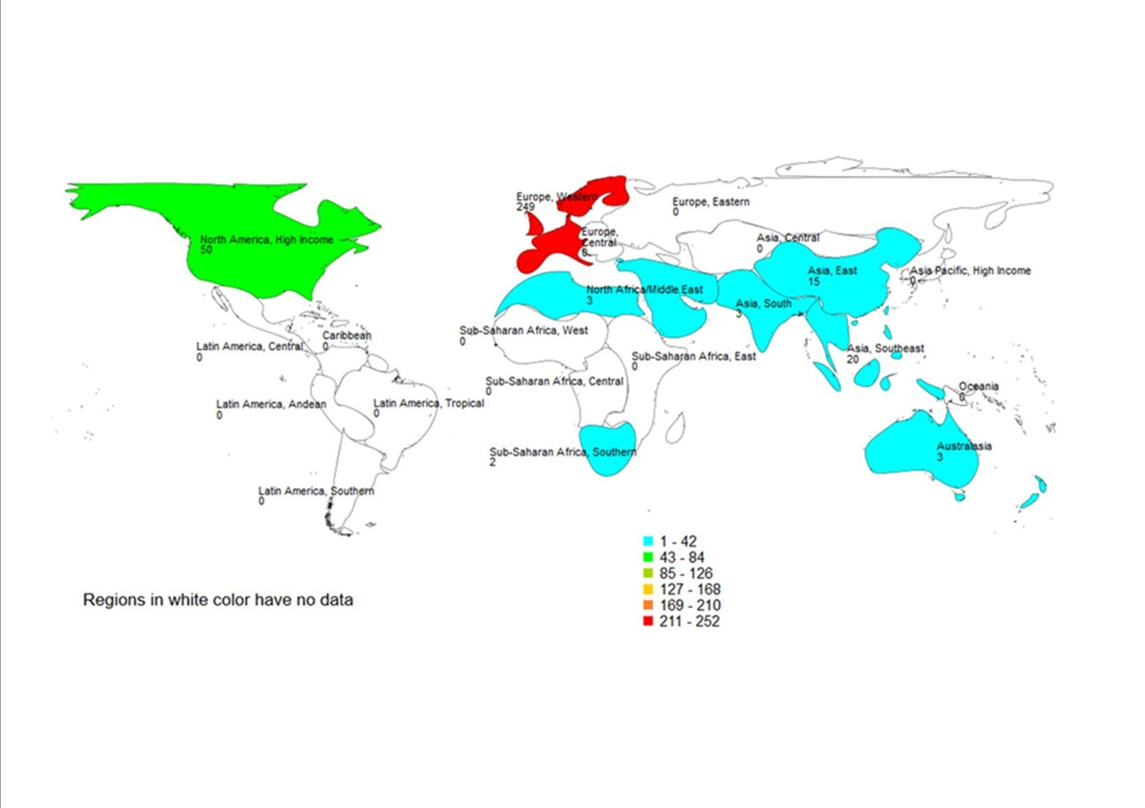

Figure 2
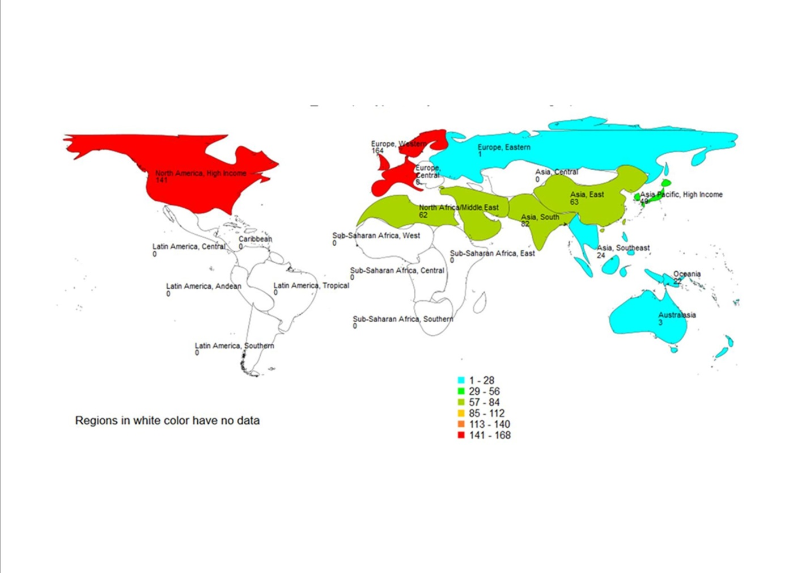

Figure 3
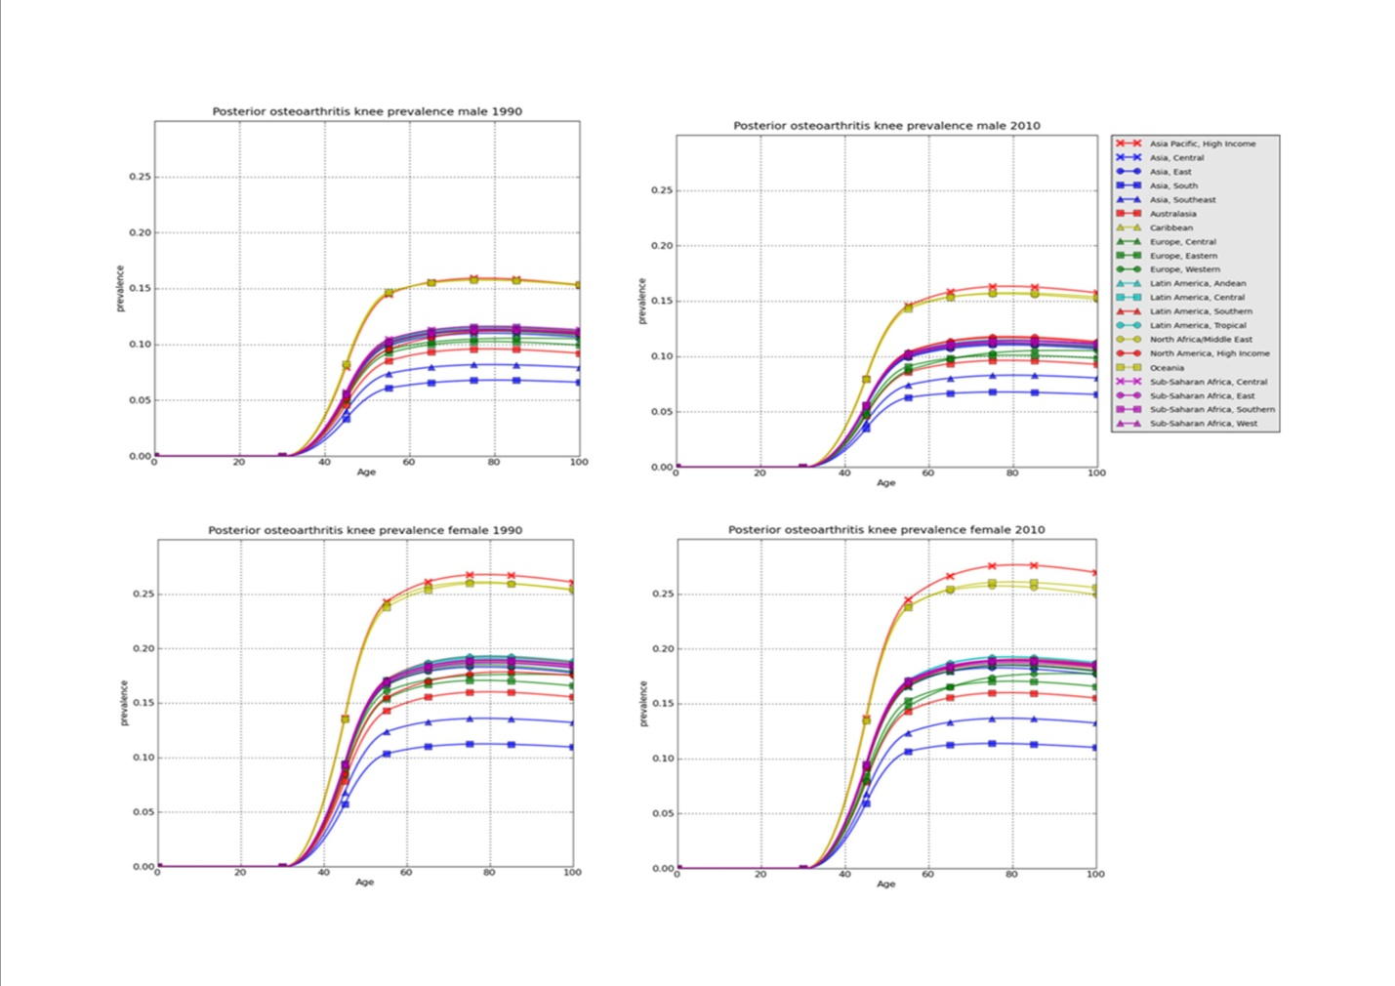

Figure 4
