A Statistical Approach to Defining Proterozoic Crustal Provinces and Testing Continental Reconstructions of Australia and Laurentia – SWEAT or AUSWUS?

C. Burrett ¹ and R. Berry ¹

¹ School of Earth Sciences, University of Tasmania, Box 252-79, Hobart, Tasmania, Australia 7001

Abstract
A new statistical method is proposed to compare crustal terranes and to cluster terranes into crustal provinces, regions and realms. Geochronological data on mafic igneous rocks, felsic igneous rocks, deformation history and Nd model age were collected from the recent literature for over 100 terranes.
The 54 selected Laurentian terranes cluster into 9 provinces including a previously well recognized very distinctive SW USA province, region and realm. The 38 selected Australian terranes cluster into six provinces including a distinctive Gawler Province. A combined dendrogram of the 100 terranes from Laurentia, Australia and Antarctica results in 8 superprovinces and 11 provinces. Five of the superprovinces contain both Laurentian and Australian terranes.
The inclusion of the Nevada-Californian Mojave and the San Gabriel Terranes in an otherwise Australian superprovince that includes Broken Hill and Mt Isa Terranes, strongly supports the AUSWUS Laurentia-Australia reconstruction rather than the SWEAT reconstruction. Low statistical similarities between western Laurentia and eastern Antarctica fail to support the SWEAT hypothesis whilst high similarities between Canadian and north Australian terranes provides weak support for AUSWUS.

Introduction
Many reconstructions of Proterozoic continental aggregations have been proposed. Several have been based mainly on paleomagnetic data, some on fits using geological piercing points and some have used a combination of both geological and paleomagnetic data. Bell and Jefferson (1987) suggested a Late Proterozoic connection between Canada and Australia. The most influential reconstruction is the SWEAT hypothesis of Dalziel (1991), Hoffman (1991) and Moores (1991) which is based on a match between the southwestern USA and the Shackleton Range area of eastern Antarctica. Several modifications of the SWEAT hypothesis have been proposed resulting in a variety of fits of Laurentia against eastern Australia-eastern Antarctica (Blewett et al., 1998; Borg and DePaolo, 1994; Idnurm and Giddings, 1995; Ross et al., 1992; Young, 1992). Li et al. (1995) further modified the SWEAT fit by placing South China between Laurentia and Australia. Burrett and Berry (2000) attempted to compare the geological histories of Laurentian and Australian terranes/domains/blocks. They concluded that a reconstruction placing California-Nevada (the Mojavia Terrane) in a re-entrant of the Tasman Line (the eastern, rifted margin of Proterozoic Australia) brought several terranes with similar Mesoproterozoic geological histories into close proximity. This reconstruction was similar to that of Brookfield (1993) which was based on lineament matching and similarities between the Neoproterozoic glacial histories of Laurentia and Australia. This reconstruction was independently proposed by Karlstrom et al. (1999) who gave it the acronym AUSWUS (Australia-Western United States reconstruction). Karlstrom et al.’s (1999) AUSWUS differs from that of Burrett and Berry (2000) by placing several Mexican terranes in the Tasman Line re-entrant.

Aims

Our aims are:
- To develop a statistical method for clustering terranes into crustal provinces.
- Define Proterozoic crustal provinces for Laurentia and Australia.
- To use the quantitative inter-terrane comparisons and the newly defined provinces to test Proterozoic paleocontinental reconstructions particularly the SWEAT and AUSWUS hypotheses.

Although our results may be suggestive our aim is NOT to use quantitative comparisons and clustering in order to develop paleocontinental terrane reconstructions.

Methodology

Blocks and terranes
We have quantitatively compared the Proterozoic geological histories of small crustal ‘blocks’ within and between Laurentia, Australia and Antarctica in order to objectively assess fits of these continents in the Late Proterozoic. We have concentrated on blocks that are now in the western half of Laurentia - a future study will assess Laurentian-Baltica-Siberia reconstructions. We have not attempted to compile information on the constituent terranes of mainly Archean blocks such as Superior, Wyoming, Yilgarn and Pilbara.
In Laurentia, some blocks are based on potential field domain mapping with supplementary data from seismic surveys, drilling and field mapping as in north west Canada (Ross 1991). Other terranes are based primarily on field and geochemical studies such as those in southwest USA (Condie 1992; Karlstrom and Bowring, 1988). In the mid-continent region of the USA, very extensive blocks are defined mainly by geochemical and geochronological studies on cores from deep drillholes (Van Schmus et al 1996).
For Australia, we have used the digital version of the Australian Crustal Elements Map (Shaw et al 1996) and modified it to show terranes recognised by regional geological studies. Shaw et al (1996) defined their crustal elements using magnetic and gravity data sets. The boundaries of some of these elements coincide with geologically recognised terranes while other boundaries outline geological trends within terranes. The geophysically defined terrane boundaries clarify the extent of terranes under younger cover and offshore. Many of Shaw et al’s (1996) element boundaries are retained in Fig. 2.
In Antarctica, outcrops are scattered around the periphery of that continent and we have selected a few outcrop belts, which appear to have a coherent geological history and where recent, precise geochronological data are available. We have not made an attempt to include all of the available Antarctic information.
An effort was made to make an entirely objective comparison of similarity between the Proterozoic terranes of North America, Australia, and Antarctica. The dataset includes four types of age information for these terranes. They are Nd TDM, mafic igneous rocks, acid igneous rocks and deformation events. We have limited our quantitative comparisons to those terranes for which we have found data for at least three of these major categories. This limitation has led to the exclusion of tectonically significant terranes such as the Shackleton Ranges, Antarctica where critical data are lacking.

Data used

Most quantitative data for Laurentia, Antarctica and Australia is based on SHRIMP zircon dating and some from Nd –Sm dating. Very few dates were derived from studies on Rb-Sr dates and none from K-Ar dates.
Data for most terranes were derived from 4 or five papers published in the last decade. However, data for a few terranes were derived from twenty papers and some from only one paper.
Data and brief references on an EXCEL spread sheet are posted on the University of Tasmania internet web site at http://www.geog.utas.edu.au/geol/research.html.

For Nd TDM data mainly a single age was used with a large error for each terrane.
For acid igneous rocks all extrusive (rhyolite) and intrusive (granitoid) events were lumped together. This was largely to maintain simplicity but also because the ratio of extrusive to intrusive rocks may reflect levels of erosion in the terranes rather than primary geological history.
Mafic intrusive events include basaltic volcanism, mafic dykes and gabbro. Deformation ages included all substantial folding and metamorphic ages but not events that only produce faults. No attempt was made to weight the probability distribution so that the most important events scored higher.

Statistical Techniques

The general question we are asking in this study is whether two blocks have the same geological history. This is grossly the statistical question: are two distributions of events in time different? The most basic tests assume that we know the form of the distribution but these are not relevant to geological histories that have complex polymodal distributions. The common methods used for testing the difference between complex distributions are the chi-squared test for binned data and the Kolmogorov-Smirnov test for continuous data (Press et al 1986 p 469-470). While the data on geological history appear to be continuous in nature, there are several significant problems. The data are very sparse with few events scattered across a long history. The data sources are complex so that the accuracy of data vary over several orders of magnitude. In some cases the events (for example deformations) continue over sufficient time that they cannot be considered instantaneous even on a geological time scale. Treating the data as continuous does not allow comparison of events that have different lengths. Simple binning (e.g. Sircombe 1999) has the same limitation and, in addition, introduces arbitrary effects. Using binning at 100 m.y intervals carried out on the preferred age, an event at 898 ± 20 Ma in one terrane would not be correlated at all with an event at 902 ± 20 Ma in another. For this reason we have binned the data using a probability distribution.
All the events were assumed to have a normal probability distribution related to the error of measurement. This error and the age were used to develop the probability distribution. Where more than one event occurred within the terrane the probability distributions were summed and divided by the number of events to maintain a total probability of one. To introduce an aspect of fuzzy logic all events were given a minimum standard error of 50 m.y. Thus while a rhyolite may have a discrete igneous age of 807 ± 4 Ma the event was calculated with a 50 m.y. standard error. This measure ensured that terranes which had a felsic igneous event within 50 m.y. would be identified as more alike than examples where the felsic rocks, nearest in age, are much more different than this. The probability distributions were broken into 100 m.y. bins that ran from 500 Ma to 3500 Ma. This produces a probability of an event having occurred in the terrane for 30 time slices (bins).
The four types of information (Nd TDM, felsic igneous events, mafic igneous events and deformations) were all treated the same way. The probabilities (120 bins) were then used to construct a distance measurement between terrane histories. Because of the complex source of data and the way it was processes the chi-squared method was not considered appropriate. The chi-squared probability function assumes a large number of events. It is also very susceptible to bins with small values. A result of using the normal function to define the probability distribution is that bins away from events have a small, but non-zero, values from the tail of the normal distribution function. As a result the assumptions of the chi-squared method are seriously violated. Therefore, we have used clustering methods to address the problem of difference between terranes. These methods do not allow an exact probability to be associated with the difference between the history of two terranes but they do give an indication of relative difference. Two types of distance measures were calculated and these were used to construct a cluster diagram using the program MVSP (Kovach, 1993). A farthest neighbor cluster routine was applied on a Manhattan Metric distance measure and a minimum variance clustering using a squared euclidean distance. The cluster routines gave similar results and only minimum variance is reported here. Swan & Sandilands (1995, Chapter 8) has an excellent introduction to clustering techniques.

Terminology
We will refer to all these blocks, domains and crustal elements loosely as terranes and to numerical clusters of these terranes as crustal provinces and sub-provinces. Many of the terranes defined in this study are fault bounded, have a distinctive assemblage of rocks, and a tectonic history different to that of surrounding terranes. They therefore fall within the terrane definition of Jones et al. (1983). Because of outcrop and mapping limitations, other terranes recognized in this study may or may not be fault bounded. Our quantitative methodology concentrates on comparing dates of events and as yet does not include comparing qualitative, often genetic, descriptors such as ‘thick turbidites’, ‘shallow water carbonates’, ‘numerous rapakivi granites’ or ‘oceanic arc basalts’. Therefore, our methodology will not, at present, separate terranes that have very different geological compositions but have very similar igneous and deformation chronologies. We plan to include these general qualitative descriptions of each terrane in a future study.
The dendrograms clearly reveal a hierarchical structure, which is duplicated by both methods of dendrogram construction. Although we realize that the construction of dendrograms may introduce a spurious hierarchy, we consider that the hierarchical structure is real and is not a statistical artifact. We will use the hierarchical nomenclature of biogeography and paleobiogeography plus terrane terminology as shown in Table I. This methodology results in a different definition of crustal province than that used by others. For instance, Condie (1992 p. 447) defines a crustal province as “a large segment of continental crust that accreted during a limited time interval” and that “although terranes in a given province may have different crustal formation ages (i.e. ages of mantle extraction), they all accrete during the same time interval to form the province”. Our methodology does identify some well known crustal provinces from their constituent terranes (e.g. Southwest USA Province and Gawler Superprovince, Australia) but may result in the inclusion in the same province of terranes that were never in close proximity or part of the same continent.

TABLE 1

Crustal Realm
Sub-realm
Super-region
Crustal Region
Sub-region
Super-province
Crustal Province
Sub-province
Super-terrane (= amalgamated terrane and some crustal elements of Shaw et al 1996)
Terrane (coincides with some crustal elements of Shaw et al 1996)
Sub-terrane (coincides with some crustal sub-elements of Shaw et al 1996)

Table 1 Hierarchy of crustal categories used in this study.

We have labelled the dendrograms (Figs. 1, 3 & 5) using the crustal categories of Table 1.

Results

The lowest value (0.1) of distance (i.e. highest similarity) between any two terranes is found between the Kimberley Block of northwest Australia (K on Fig. 4) and the Great Bear Terrane of Canada (GB on Fig. 2) but, generally, distance index (DI) values below 1.0 are uncommon. We assume DI values below 0.5 indicate a very high level of similarity.

Laurentian Crustal Provinces

The 54 Laurentian terranes (Fig. 1) cluster into two crustal realms. A surprising result of this study is the distinctiveness of the 1790-1670 Ma southwestern USA arc and back arc terranes, which form the mono-regional, bi-provincial Realm 1. The two provinces identified, however, do not correspond to the Yavapai and Mazatzal provinces of Karlstrom and Bowring (1988) and Condie (1992). Laurentian Province 1 contains both Mazatzal and Yavapai terranes whereas Province 2 consists of three of the Yavapai terranes, (Ash Creek, Dubois and Hualapai) plus the Black Hills of Dakota.
Laurentian Realm 2 consists of 3 regions containing 8 provinces. Region 2 consists of the Grenvillian age peri-Laurentian terranes in Province 3, the older (1750-1550 Ma) peri-Laurentian cratonic terranes of Province 4, the internal, early-pre-Grenvillian terranes of Province 5 and the early-Grenvillian terranes of Texas and New Mexico. Region 3 consists of the Neoarchean-Paleoproterozoic (2.4-1.9 Ga) terranes of Province 7, the Neoarchean-Paleoproterozoic (1.95-1.84Ga) terranes of Province 8 and the Archean (3.3-2.6Ga) terranes of Province 9. Region 4 consists of the Paleoproterozoic (1.89-1.79 Ga) terranes of Province 10.

Australian Crustal Provinces

The 38 Australian terranes combine into two realms (Fig. 3) with Realm 1 consisting of the five Paleoproterozoic terranes in Province 7. Realm 1 consists of two regions each consisting of 3 provinces. Province 1 consists of peri-Australian Neoproterozoic terranes deformed between 1Ga and 0.8Ga. Province 2 consists of 1.8-1.55 Ga terranes in eastern and northern Australia. Province 3 consists of 1.9-1.59 Ga terranes in and around the Gawler Craton of South Australia.
Region 2 consists of Province 4 Neoproterozoic (Adelaidean) peri-Australian terranes, Province 5 of Archean and Paleoproterozoic terranes in central and western Australia and Province 6 consists of peri-Australian ‘Grenville’ terranes in Queensland and Western Australia.

Laurentia-Australia-Antarctica Dendrogram

A comparison of 100 terranes from Laurentia, Australia, Antarctica and the Falkland Islands results in two realms, 5 regions, 8 superprovinces and 11 provinces (Fig. 5). The 8 superprovinces are shown on the maps of Figs. 6 & 7.
Realm 1’s Superprovince 1 contains 22 Archean to Paleoproterozoic terranes from all three continents. Superprovince 2 is the same as the peri-Australian Province 1 with the addition of Central Queen Maud Land (Antarctica) and Superprovince 3 is the same as Laurentian Province 5 (Belt Basin Terrane plus two Eastern Granite Rhyolite Terranes). Superprovince 4 consists of Grenvillian terranes in all three continents.
Realm 2’s Superprovince 5 is the same as Australian Province 5 with the addition of the Mojave and San Gabriel Terranes (Barth et al., 2000) of California-Nevada and the Terre Adelie Terrane (Antarctica). Superprovince 6 contains both peri-Laurentian and peri-Australian terranes plus the Gawler Craton terranes of South Australia. Superprovince 7 is the same as Laurentian Realm 1 consisting of the SW USA and Mexican arc terranes. Superprovince 8 contains two Paleoproterozoic provinces one Laurentian and the other containing both Laurentian and Australian terranes.

Interpretation

It is commonly argued that if two blocks were formerly contiguous then their geological histories should be very similar. Our methodology may therefore be used to test various hypotheses of paleocontinental placements. It is not designed to construct hypotheses and low DI’s do not a priori suggest paleocontiguity although the DI data base may well provide clues for the construction of tectonic hypotheses.
The co-provincial occurrence of both Antarctic and Australian terranes is not surprising as contiguity of Antarctica and Australia in the Late Proterozoic has been generally accepted for 35 years. Thus there is general agreement that the Terre Adelie (Antarctica) – Broken Hill (Australia) DI of 0.3 confirms former contiguity of these two terranes. We suggest that the Mojave DI’s with Terre Adelie (0.5), Broken Hill (0.5), Mt Isa East (0.6) and Olary (0.6) also suggest former proximity (Burrett and Berry 2000). This proximity is reinforced by co-provincialism of Mojave and Broken Hill lead isotopes (Burrett and Berry, 2000) and close similarities in the trace element geochemistry of Broken Hill and Mojave granites (Fig. 8). The lowest DI between the San Gabriel Terrane (California) and any terrane is with the Mt Isa West Terrane (Australia) (DI=0.7) followed by 0.8 with the presently adjacent Mojave Terrane.
The low DI’s found between several Canadian and northern Australian terranes (also see Compston, 1995) are more easily explained on the AUSWUS reconstruction (Fig.7) than on the SWEAT (Fig.6). For instance the DI of 0.1 between the Kimberley and Great Bear Terranes could be the result of a hypothetical connection above a Paleoproterozoic subduction zone to the present day north of Australia. Similarly the Rimbey – Arunta DI of 0.5 could be due to connection along a formerly contiguous supra-subduction volcanic arc from central Australia to Alberta. Such connections are far less likely if the SWEAT reconstruction is correct (Fig. 6).
On the SWEAT reconstruction, moderately high DI values (all > 1.2) are found between proposed adjacent Laurentian and Australian or Antarctic terranes. These are shown in Table II.

Dissimilarity Index (DI)
Western Tasmania
Fort Simpson 2.6

Wernecke 1.3

Nahanni 2.3

Miller Range Mojave 1.5
Belt 2.6
Priest River 1.9
Rimbey 1.6
Wyoming 1.8

Broken Hill Wernecke 1.3
Nahanni 1.4
Fort Simpson 1.9

Adelaidean Nahanni 1.7
Wernecke 1.2

TABLE 2 Selected Distance Indices (DI’s) between possibly adjacent terranes on the SWEAT reconstruction.

The high DI’s found between adjacent terranes in the SWEAT hypothesis do not support that reconstruction. However, the low DI’s found between some Australian-Antarctic terranes and Mojave and San Gabriel Terranes clearly support the AUSWUS reconstruction (Fig.7). Less clear support for AUSWUS, is provided by the low DI’s between some Canadian and northern Australian terranes.
Rogers et al. (2001) have proposed a possible Mesoproterozoic supercontinental reconstruction with the relative positions of Laurentia, Antarctica and Australia based on the SWEAT reconstruction. The close geological similarities between the Californian terranes and Australia and between some northern Australian and Canadian terranes remain unexplained on this reconstruction.
Low similarities between the Mexican terranes of Caborca and Chihuahua and Australian terranes do not support their placement in the Tasman Line re-entrant (Karlstrom et al. 1999) nor do they support the similarities suggested between Tasmania and Caborca by Burrett and Berry (2000). However, the Mexican terranes and Tasmania are allochthonous with respect to Laurentia and Australia respectively and until their geological histories are clarified, their Late Proterozoic paleopositions remain enigmatic.

Paleomagnetism

In order to test further the SWEAT and AUSWUS reconstructions we have selected paleomagnetic data for Laurentia and Australia from McElhinny and Lock (2001). Only poles identified as primary, dated to within 40 m.y. and with alpha 95’s of 16⁰ are selected. There are very few periods during the Proterozoic where there are reliable poles for both continents. Three periods have been chosen for comparison: 1750-1600 Ma, ca. 1100 Ma, and 800-700Ma (Fig.9). We have rotated Laurentia and the Laurentian poles using the euler poles of rotation for AUSWUS and SWEAT, leaving Australia and its poles in the present reference frame. Figure 9 shows that there is slightly more overlap at 1750-1600Ma on the AUSWUS reconstruction than for SWEAT but that there remains significant non-overlap for both AUSWUS and SWEAT. For ca 1100Ma there is slightly better overlap for AUSWUS and for 800-700 Ma the overlap is about the same for both reconstructions.
Rotated poles younger than 700Ma show little similarity between Laurentia and Australia. This may be due to continental separation at about 700 Ma (Li et al. 1995) or to widespread remagnetisation of key paleomagnetic poles in the Adelaide foldbelt at 586Ma (Foden et al. 2001). Widespread rift-related alkaline basalts and trachytes and seaward dipping reflectors suggest a major rifting event along the southern margin of the Tasman Line at about 586Ma (Crawford et al., 1997; Direen and Crawford, 1998).

Conclusions

Our quantitative comparison of 100 Laurentian, Antarctic and Australian terranes defined 7 crustal provinces in Australia and 10 in Laurentia. Comparing Laurentia, Australia and Antarctic terranes results in the definition of 11 provinces and 8 crustal superprovinces. Eleven southwest USA terranes, plus the Caborca (Mexico) Terrane and the Black Hills, (Dakota) Terrane remains a distinctive crustal region. Another distinctive superprovince consists of three Laurentian terranes (Belt and two Eastern Granite Rhyolite Terranes). Superprovince 2 consists of an Antarctic and three peri-Australian terranes but the other 5 superprovinces contain both Australian and Laurentian terranes.
This study supports the AUSWUS reconstruction of Karlstrom et al (1999) and Burrett and Berry (2000) rather than the SWEAT hypothesis of Moores (1991), Dalziel (1991) and Hoffman (1991). The low Distance Indices (DI’s) between the Mojave and San Gabriel Terranes, and the Mt Isa, Broken Hill and Terre Adelie Terranes, along with similarity in granite compositions (Fig.9) and co-provincialism of lead isotopes (Burrett and Berry, 2000; Wooden and DeWitt 1991) and neodynium isotopes (Bennett and DePaolo 1987; McCulloch 1987) suggest proximity of these terranes during the Mesoproterozoic. Similarly low DI’s between certain Canadian and northern Australian terranes suggests connections during the Paleoproterozoic.

Acknowledgements

We thank John Rogers, June Pongratz and Mike Roach for their help.

References

Barth, A.P., Wooden, J.L., Coleman, D.S., and Fanning, C.M., (2000) Geochronology of the Proterozoic basement of southwesternmost North America and the origin and evolution of the Mojave crustal province, Tectonics v.19, pp. 616-629.
Bell R., and Jefferson, C., (1987) An hypothesis for an Australian-Canadian connection in the Late Proterozoic and the birth of the Pacific Ocean: Proc.Pacific Rim Congress ’87, Melbourne, Australian Inst. Min. Metallurgy pp. 39 – 50.
Bender, E., Morrison, J., Anderson, J., and Wooden, J., (1993) Early Proterozoic ties between two suspect terranes and the Mojave Crustal Block of the southwestern U.S., Journal of Geology v. 101, pp. 715-728.
Bennett, V.C., and DePaolo, D. J., (1987) Proterozoic crustal history of the western United States as determined by neodymium isotopic mapping, Geological Society of America Bulletin v. 99, pp. 674-685.
Blewett, R., Black,L.P., Sun,S-s., Knutson,J., Hutton,L.J., and Bain,J.H., (1998) U-Pb zircon and Sm-Nd geochronology of the Mesoproterozoic of North Queensland: implications for a Rodinian connection with the Belt Supergroup of North America, Precambrian Research v. 89, pp. 101-127.
Boger, S.D., Wilson, C.J.L., and Fanning, C.M., (2001) Early Paleozoic tectonism within the East Antarctic craton: The final suture between east and west Gondwana, Geology v.29, pp. 463-466.
Borg, S., and DePaolo, D., (1994), Laurentia, Australia and Antarctica as a Late Proterozoic supercontinent, Geology, v. 22, pp. 307-310.
Brookfield, M., (1993) Neoproterozoic Laurentia-Australia fit, Geology v. 21, pp. 683-686.
Burrett, C., Long, J., and Stait, B., (1990) Early to Middle Paleozoic biogeography of Asian terranes derived from Gondwana, Geological Society London Memoir v. 12, pp.163-174
Burrett, C., and Berry, R., (2000) Proterozoic Australia-Western United States (AUSWUS) fit between Laurentia and Australia, Geology v.28, pp.103-106.
Compston, D., (1995), Time constraints on the evolution of the Tennant Creek block, northern Australia, Precambrian Research v. 71, pp. 107-129.
Condie, K.C., (1992), Proterozoic terranes and continental accretion in southwestern North America, in Condie,K.C., ed., Proterozoic Continental Evolution: Amsterdam, Elsevier, pp. 447-480.
Crawford, A.J., Stevens, B., and Fanning, M., (1997) Geochemistry of Late Proterozoic tholeiitic flood basalts, Adelaide Geosyncline, South Australia, Geological Society of Australia Special Publication v.16, pp. 49-67.
Dalziel, I., (1991) Pacific margins of Laurentia and East Antarctica as a conjugate rift pair: Evidence and implications for an Eocambrian supercontinent, Geology v. 19, pp. 598-601.
Direen, N., and Crawford, A., (1998) Evidence for the timing of continental breakup and volcanic passive margin formation, southeastern Gondwana: an actualistic perspective, Geological Society of Australia Abstracts v. 50, pp. 24-28.
Foden, J., Barovich,K., Jane, M., and O’Halloran, G., (2001) Sr-isotope evidence for Late Neoproterozoic rifting in the Adelaide Geosyncline at 586 Ma: implications for a Cu ore forming fluid flux, Precambrian Research v.106, pp.291-308.
Hoffman, P., (1998) The United Plates of America, the birth of a craton, Annual Review Earth Planetary Science v. 16, pp. 543-603.
Hoffman, P., (1991) Did the breakout of Laurentia turn Gondwanaland inside-out?, Science v. 252, pp. 1409-1412.
Idnurm, M., and Giddings, J.W., (1995) Paleoproterozoic-Neoproterozoic North America-Australia link; new evidence from paleomagnetism, Geology v. 23, pp. 149-152.
Jones, D. L., Howell, D.G., Coney, P.J., and Monger, J.W., (1983) Recognition, character and analysis of tectonostratigraphic terranes in western North America. In: M.Hashimoto and S.Nyeda (eds.) Advances in Earth and Planetary Sciences. Terra Scientific Publishing Co. Tokyo, pp. 21-35.
Karlstrom, K. E., and Bowring, S. A., (1988) Early Proterozoic Assembly of Tectonostratigraphic Terranes in Southwestern North America, Journal of Geology v. 96, pp. 561 – 576.
Karlstrom, K. E., Harlan, S. S., Williams, M. L., McLelland, J., Geissman, J. W., and Ahall, K-I., (1999) Refining Rodinia: Geologic evidence for the Australia - western U.S. connection in the Proterozoic: GSA Today, v. 9, pp. 1 -7.
Kovach, W.L. (1993) MVSP – a Multivariate Statistical Package for IBM-PC’s ver 2.1. Kovach Computing Services, Pentraeth, Wales.
Lafrance, B., Clarke, G., Collins, W., and Williams, I., (1995) The emplacement of the Wuluma Granite: melt generation and migration along steeply dipping extensional fractures at the close of the Late Strangways event, Arunta Block, central Australia, Precambrian Research v. 72, pp. 43-67.
Li, Z-X., Zhang, L., and Powell, C., (1995) South China in Rodinia: part of the missing link between Australia-east Antarctica and Laurentia?, Geology v. 23, pp. 407-410.
McCulloch, M., (1987) Sm-Nd Isotopic constraints on the evolution of Precambrian crust in the Australian continent: Proterozoic lithospheric evolution, American Geophysical Union Geodynamics Series v.17, pp. 115-130.
McElhinny, M. and Lock, J., (2001) Global Paleomagnetic Database, Internet Site of NOAA World Data Center A, Boulder Colorado, http:/www.ngdc.noaa.gov.
Moores, E., (1991) Southwest U.S.-East Antarctic (SWEAT) connection: a hypothesis, Geology v. 19, pp. 425-428.
Pearce, J.A., Harris, N.B., and Tindle, A.G., (1984) Trace element discrimination diagrams for the interpretation of granitic rocks, Journal of Petrology v. 25, pp.956-983.
Press, W.H., Flannery, B.P., Teukolsky, S.A. and Vetterling, W.T., (1986) Numerical recipes, the art of scientific computing. Cambridge University Press, Cambridge UK.
Reed, J.C., Bickford,M.E., Houston, R.S., and Link,P.K., (eds.) (1993) Precambrian Conterminous U.S., The Geology of North America, Boulder, Colorado, Geological Society of America, v.C-2, 1-603.
Rogers, J.J.W., Santosh, M., and Yoshida, M., (2001) Mesoproterozoic Supercontinent, Internet site http://baby.indstate.edu/gga/gr
Ross, G., (1991) Precambrian basement in the Canadian Cordillera: an introduction, Canadian Journal Earth Science v. 28, pp. 1133-1139.
Ross G., Parrish, R., and Winston, D., (1992) Provenance and U-Pb geochronology of the Mesoproterozoic Belt Supergroup (United States): implications for age of deposition and pre-Panthalassa plate reconstructions, Earth and Planetary Science Letters v. 113 pp. 57-76.
Shaw, R., Wellman, P., Gun, P., Whitaker, A., Tarlowski, C., and Morse, M., (1996) Guide to using the Australian crustal elements map, Australian Geological Survey Organisation Record v. 1996/30, pp. 1-20.
Sircombe, K.N., (1999). Tracing provenance through the isotope ages of littoral and sedimentary detrital zircon, eastern Australia. Sedimentary Geology v. 124, 47-67.
Swan, A.R.H. and Sandilands, M. (1995). Introduction to geological data analysis. Blackwell Science, Oxford 446 pp.
Van Schmus, W.R., Bickford, M.E., and Turek, A., (1996) Proterozoic geology of the east-central Midcontinent basement, Geological Society America Special Paper v. 308, pp. 7-44.
Vassallo, J.J.,and Vernon, R.H., (2000) Origin of megacrystic felsic gneisses at Broken Hill, Australian Journal of Earth Sciences v.47, pp. 733-748.
Webster, A., (1996) Delamerian refolding of the Palaeoproterozoic Broken Hill Block, Australian Journal of Earth Sciences v.43, pp.85-89.
Weil, A.B., van der Voo, R., Niocaill, C.M. and Meert J.G., (1998) The Proterozoic supercontinent Rodinia: paleomagnetically derived reconstructions for 1100 to 800 Ma., Earth and Planetary Science Letters v.154, pp. 13-24.
Wooden, J.L., and DeWitt, E., (1991) Pb isotope Evidence for the boundary between the Early Proterozoic Mojave and Central Arizona crustal provinces, Arizona Geological Society Digest v.19, pp. 27-50.
Young, G., (1992) Late Proterozoic stratigraphy and the Canada-Australia connection, Geology, v.20, pp.215-218.

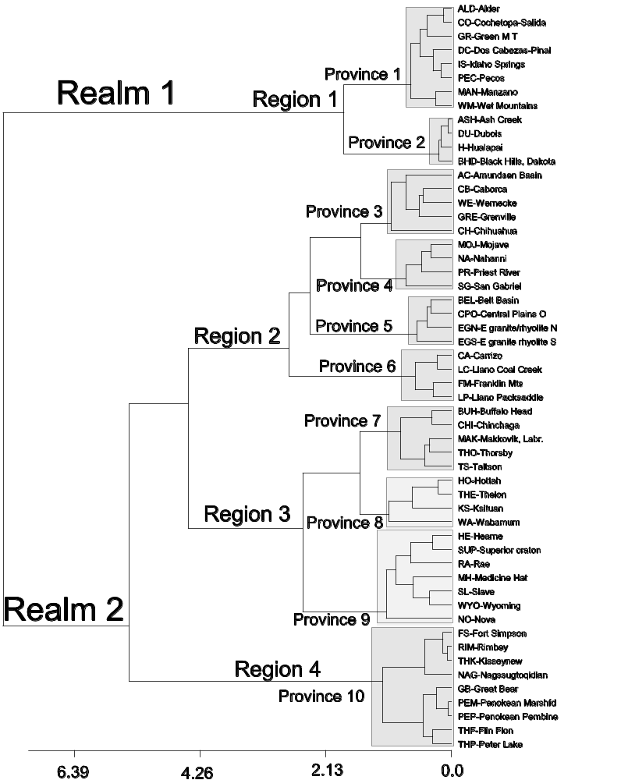

Figure 1 Minimum Variance Dendrogram for 54 selected terranes from Laurentia.
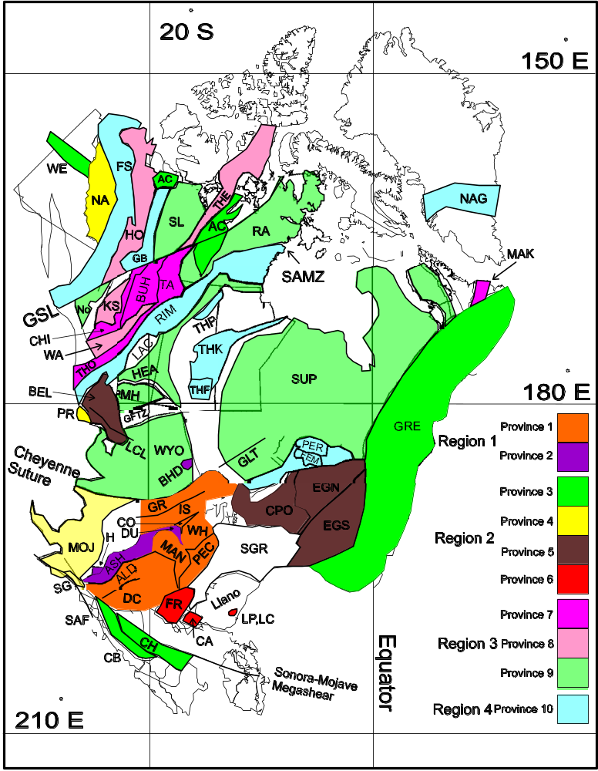
Figure 2 Map of Laurentia showing location of the 10 provinces from Fig.1. Abbreviations of terranes are listed in Fig.1. GFTZ =Great Falls Tectonic Zone, GLT = Great Lakes Tectonic Zone, GSL= Great Slave Lake Shear Zone, LCL =Lewis and Clark Line, SAF = San Andreas Fault and SAMZ = Striding Athabasca Mylonite Zone. Western margin of Proterozoic Laurentia is taken as the 0.706 ⁸⁷Sr/⁸⁶Sr isopleth (Reed et al (1993). Laurentia is oriented using 1100Ma Laurentian paleomagnetic pole: paleonorth is to right of figure. Mercator projection.
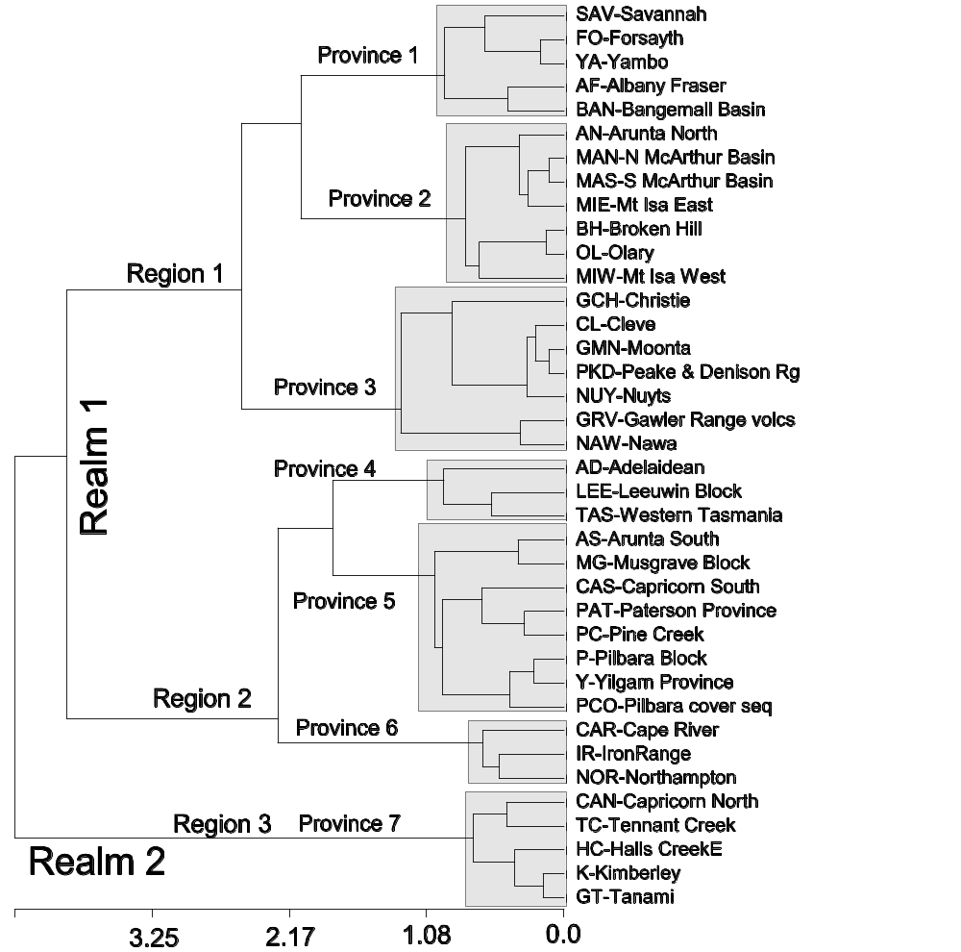
Figure 3 Minimum Variance Dendrogram of 38 Australian terranes.
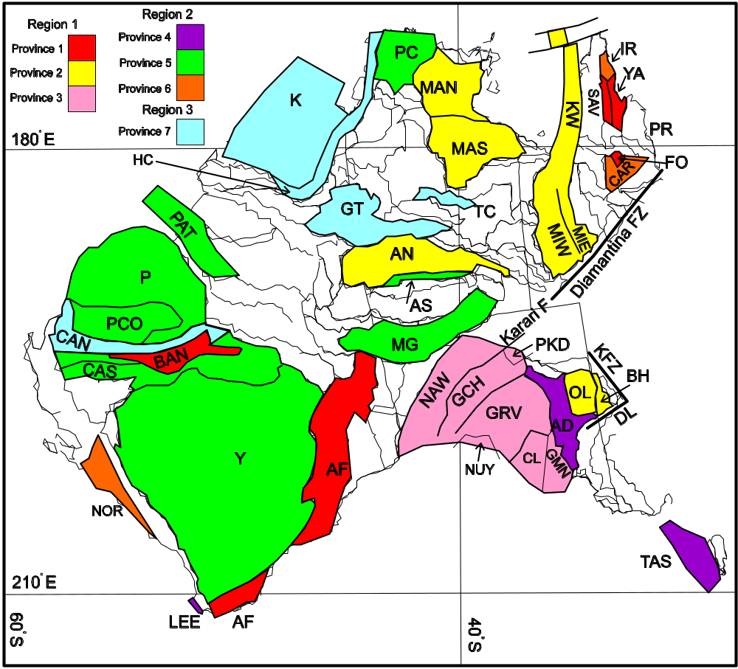
Figure 4 Map showing 38 Australian terranes clustered into 7 provinces from Fig. 3. Abbreviations of terranes are listed in Fig.3. DL= Darling Lineament, KFZ = Koonenberry Fault Zone. Eastern margin of Proterozoic Australia is taken as Tasman Line as defined by major lineaments (Li et al 1995). Australia is oriented using 1100Ma Australian paleomagnetic pole: paleonorth is to right of figure. Mercator projection.
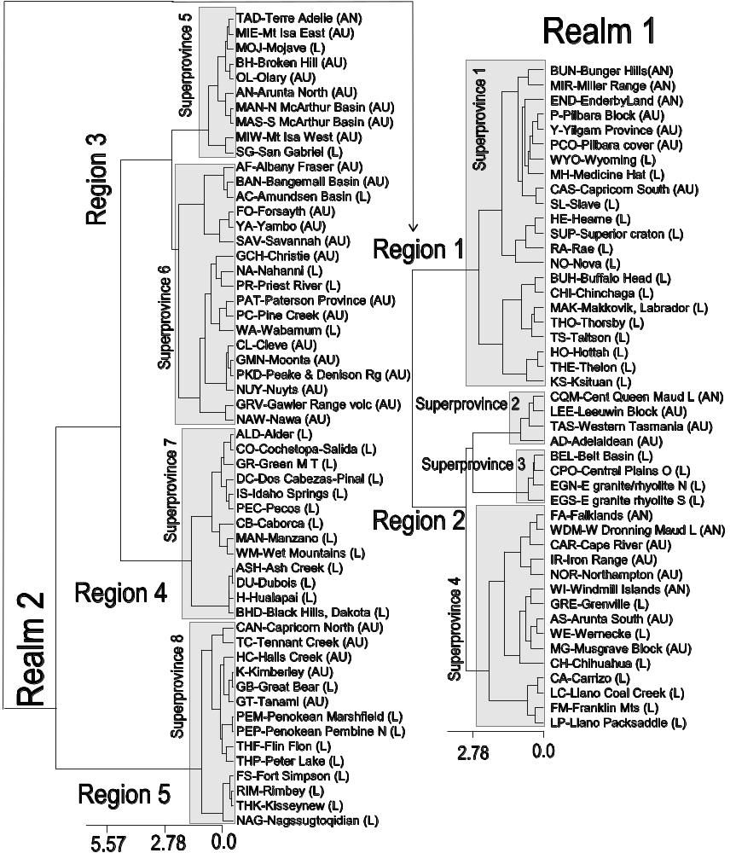
Figure 5 Minimum Variance Dendrogram based on 100 Antarctic, Australian and Laurentian terranes.
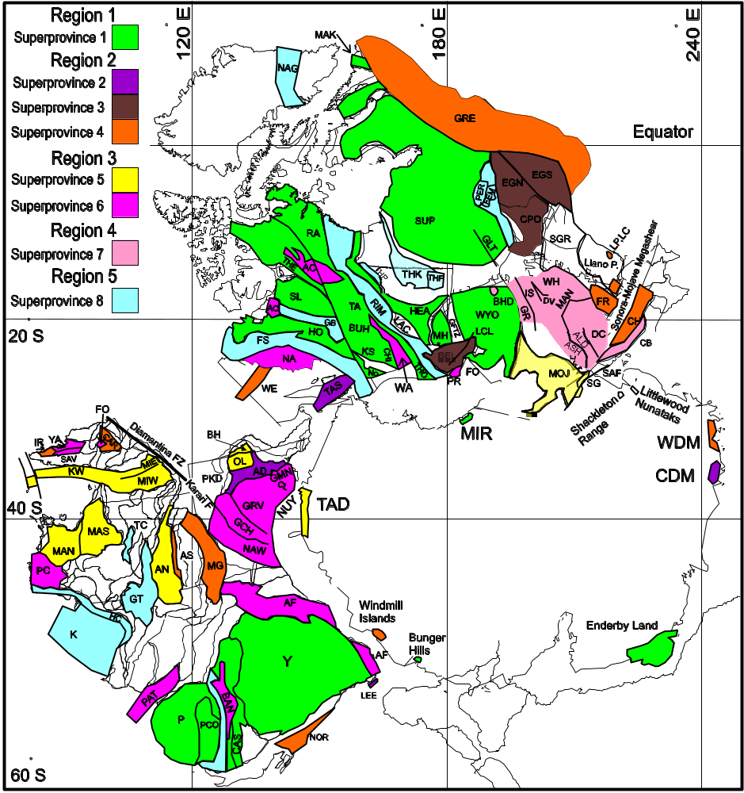
Figure 6 SWEAT reconstruction of East Antarctica, Australia and Laurentia showing combined superprovinces of Fig. 5. Oriented with respect to Australian 1100Ma paleopole. Continents combined using “SWEAT” euler poles listed by Weil et al (1998). Continents assembled and rotated using program written by Berry and used in Burrett et al (1991). Paleonorth is towards top of figure. Terrane abbreviations are given in Fig.5. GLT=Great Lakes Tectonic Zone, GFTZ = Great Falls Tectonic Zone, SAF=San Andreas Fault.
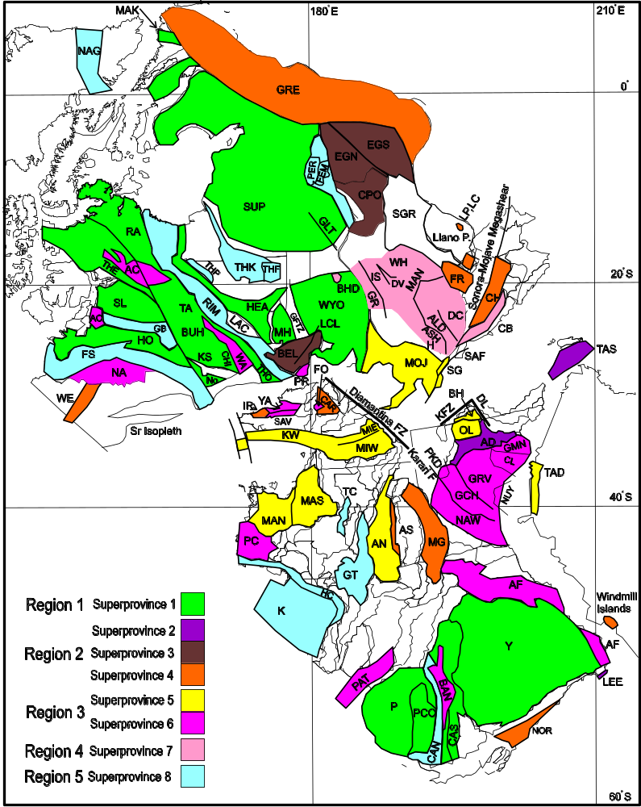
Figure 7 AUSWUS reconstruction of East Antarctica, Australia and Laurentia showing combined superprovinces of Fig. 5. Oriented with respect to Australian 1100Ma paleopole. Laurentia rotated to Australia about an euler pole at 50.5⁰N, 111.5⁰E with a rotation angle of 171.6 (Burrett and Berry 2000). Paleonorth is towards top of figure. Terrane abbreviations are given in Fig.5. GLT=Great Lakes Tectonic Zone, GFTZ = Great Falls Tectonic Zone, SAF=San Andreas Fault.

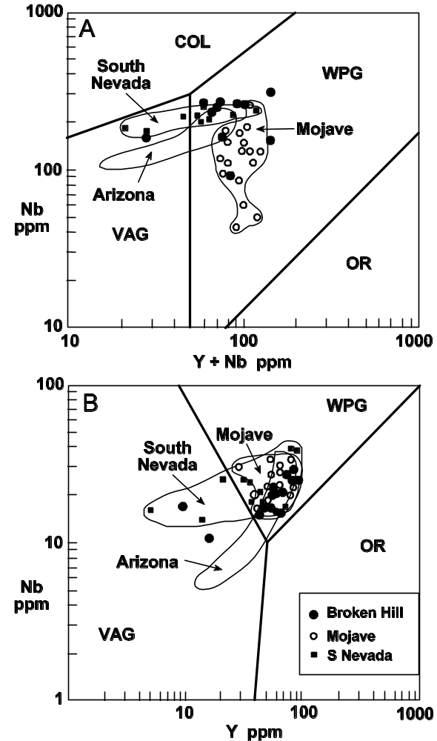
Figure 8 Nb, Y and Rb abundances for 1.63-1.69 granites of the Mojave block, south Nevada (also Mojavia), central Arizona (Region 1 of Fig. 1) and Broken Hill (New South Wales, Australia). Laurentian data is from Bender et al (1993) and Australian data from Vassallo and Vernon (2000). Boundaries for VAG (volcanic arc granite), OR (ocean ridge granite) and COL (collisional granite) from Pearce et al. (1984).
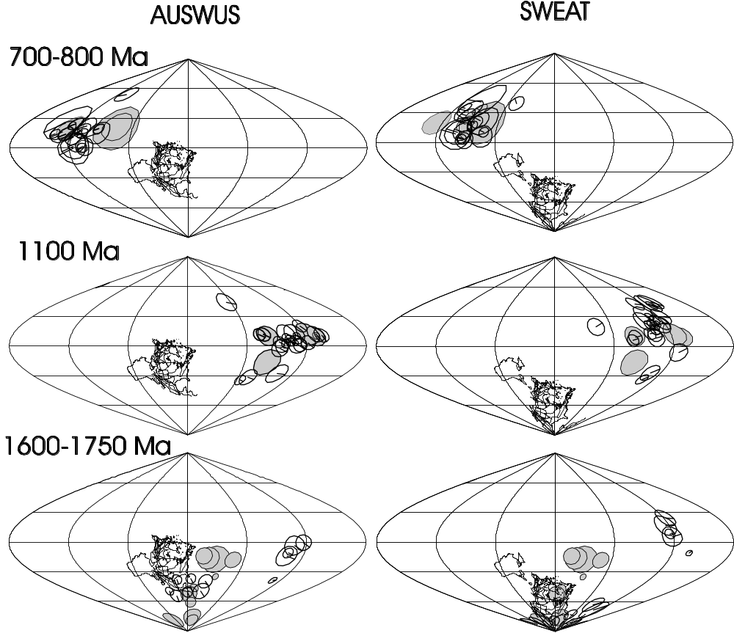
Figure 9 Paleomagnetic comparison of AUSWUS and SWEAT hypotheses. Australia is in present-day position and Laurentia and Laurentian poles rotated about euler poles to obtain AUSWUS and SWEAT reconstructions. Poles are shown with alpha 95’s and with Australian poles shaded.

