Transient Stability Improvement Using
Non-superconducting Fault Current Limiter

M. Tarafdar Hagh, M. Jafari, S. B. Naderi
Faculty of Electrical and Computer Engineering, University of Tabriz,
Tabriz, Iran
Emails: tarafdar@tabrizu.ac.ir, m.jafari.elc@gmail.com, s.b.naderi@gmail.com

Abstract-In this paper, transient stability of Single Machine Infinite Bus (SMIB) system with a Non-superconducting Fault Current Limiter (NSFCL) is proposed. Analytic analysis of system stability is discussed in detail and as result, optimal value of NSFCL resistance during fault that leads to effective improvement of stability is calculated. Equal area criterion is used for this calculation. Study system is simulated by EMTDC/PSCAD to verify the effectiveness of the optimal resistor value of the proposed NSFCL.
- Introduction
As electric power systems grow and become more interconnected, at some points, the available fault currents level may exceed the maximum short-circuit ratings of the switchgear. Traditionally, to alleviate the cost of switchgear and bus replacements, the most common ways to limit high-level fault currents are: up rating of switchgear and other equipment, splitting the power grid and introducing higher voltage connections (AC or DC), using current-limiting fuses or series reactors or high-impedance transformers, and using complex strategies like sequential network tripping [1].
A novel idea to limit the fault currents and prevent up grading of the switchgears is usage of FCLs. The implementation of FCLs in electric power systems is not restricted to suppress the amplitudes of the short circuits; they are also utilized to variety of performances such as the power system transient stability enhancement, power quality improvement, reliability improvement, increasing transfer capacity of system equipment, and inrush current limitation in transformers [2]-[5].
Recent studies on system applications of FCLs are done on superconducting types FCLs, mostly. At stability issues, they are discussing on Resistive type SFCL (RSFCL) and its effect on transient stability of system, in general [6]-[11]. RSFCL is capable of consuming the excessive accelerating generator power, increasing the stability-limit of the system and then enlarging the stability-region after the short circuit.
In some papers, optimum value for resistor of superconductor at fault interval which leads to best improvement of stability is discussed [8], [11]. They try to make a RSFCL that has optimal resistor value at fault condition. But there are two problems. Firstly, because of high technology and cost of superconductors, these devices are not commercially available, unfortunately. Especially in third world countries, design, manufacture and operation costs providing is impossible approximately. Secondly, resistance that RSFCL shows at fault condition is not constant during the fault due to its quenching characteristics [8]. So, it is not possible to equate RSFCL’s resistance to calculated optimal value.
In this paper, a topology of non-superconducting FCL is introduced and its effect on transient stability of power system is studied. Analytic analysis of stability for pre-fault and during fault conditions is presented in detail. Equal area criterion is used to calculate the optimum value of resistance which leads to maximum critical load angle. Simulation results are performed by EMTDC/PSCAD and analytic analysis is presented..
- Power circuit topology of NSFCL and its operation
Fig. 1 shows the three phase topology of proposed NSFCL.
This circuit is composed of four main parts that are described as follows.
- Three sets of single phase transformers, utilized as power isolation transformer, are connected to a three-phase diode bridge rectifier. The three phase diode bridge is called “isolation transformer rectifier”.
2) A non-superconductor (copper coil) magnet that is modeled by a resistor () and an inductor (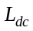).

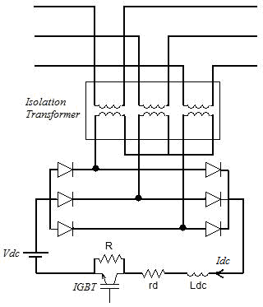
Figure. 1. Three phase topology of proposed NSFCL
3) A parallel connection of a resistor () and a semiconductor switch (IGBT) that are connected in series with the dc reactor.
4) A dc voltage source (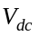) used to compensate the voltage drop that take place in both dc reactor resistance and semiconductor devices. So, it equals to [12]:

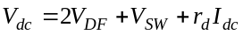 (1)

Where 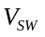 stands for the voltage drop across IGBT and the forward voltage drop across rectifier diodes is defined as 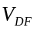.
In normal operation of utility, the semiconductor switch is closed and the resistor is bypassed. By choosing appropriate value for , it is possible to achieve an almost dc current through the dc reactor. By compensating voltage drop on semiconductor devices and natural resistance of dc reactor, voltage drop on NSFCL becomes almost zero and consequently it does not affect normal operation of system.
As fault occurs, the current of dc reactor starts to charge. When its current reach to a pre-defined value, control system operates and turns off the IGBT. So, enters to the current path and limits the fault current. After removal of the fault, IGBT turns on and FCL returns to pre-fault condition.
By selecting proper value for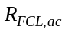 (Resistance that NSFCL shows in fault condition at ac side of rectifier bridge), power system will have maximum transient stability at fault situations.
Value of is proportional to value of . It is important to note that, value of doesn’t effect the impedance of NSFCL.
- Transient Stability Study on Power System with NSFCL
Fig. 2 shows single line view of power system with proposed NSFCL. In the pre-fault condition, transfer power can be expressed by:

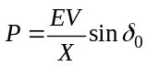 (2)
Where:
: RMS line to line synchronous generator voltage
: RMS line to line infinite bus voltage
: Total reactance (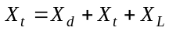)
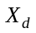: Unsaturated reactance of generator
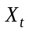: Transformer reactance
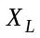: Line reactance
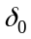: Load angle
As a fault occurs at point F, without NSFCL, transfer power is reduced (depends on fault type).
In this state, if a consumer of active power doesn’t exist between generator and point F, Synchronous generator will be unstable probability. That means, even, using SFCL (Inductive type) can not ensure stability of generator. So, a resistor must be entered to line during fault. In addition, at fault condition, mechanical power (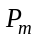) is assumed constant.
Fig. 3 shows the equivalent circuit at fault state by using NSFCL, after applying star to delta transformation in Fig. 2.
Output current of generator, 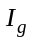, is calculated by:

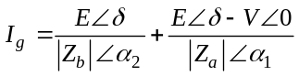 (3)
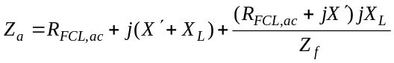 (4)
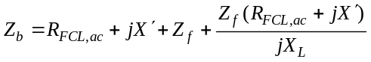 (5)
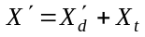 (6)

Where 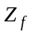 and 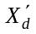 are fault impedance and unsaturated transient respectively. Electrical power of system (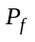) can be expressed by:

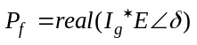 (7)
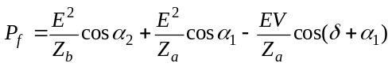 (8)

Equation (8) is sum of transfer power and consumed power of NSFCL resistance. In worst condition (three phase fault), , is equal to zero, approximately. In this state and considering (4) and (5), 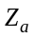 is infinite and 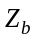 is equal to 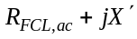. So, electrical power can be defined as follow:

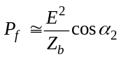 (9)

Equation (9) depends on , in fact, value of must be chosen in a way that critical load angle be maximum. In next section, optimum is achieved and analytical analyses are explained in detail.
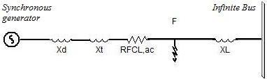
Figure 2. Single line view of power system

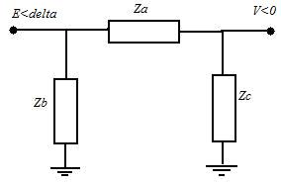
Figure 3. The equivalent circuit after transformation
- Optimal Resistor Calculation Using Equal Area Criterion
By using (2) and (9), power-angle curve is plotted in Fig. 4. Region A1 and A2 are accelerating and de-accelerating regions, respectively. Applying the equal area criterion to the power-angle curve gives the critical load angle (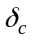), which is the boundary point to make the system remain stable.
To calculate , (10) can be used:

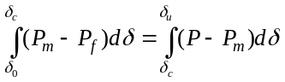 (10)

Consequently:

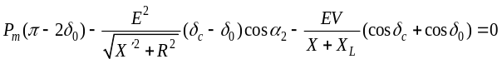 (11)

To achieved maximum , from (11), derivative is taken respect to . In this case, optimum which leads to maximum , can be expressed by:

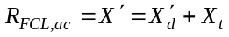 (12)

Fig. 5 shows variation of corresponding to . It is obvious that for 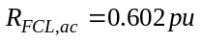, maximum value for is obtained. In other word, this is the best value for enhancement of stability region of power system.
The resistance that NSFCL shows at fault condition () is not equal to numerical value of dc side resistor of diode rectifier bridge (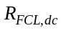). Therefore, value of should be calculated according to optimum value.
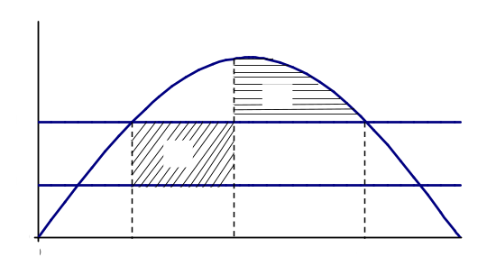
Figure 4. Power-angle curve during steady state and fault condition
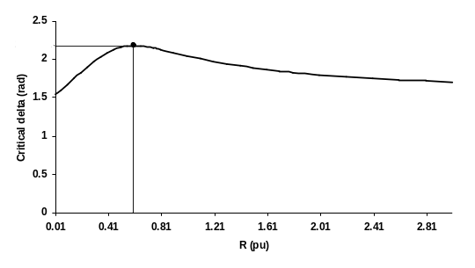
Figure 5. Variation of corresponding to 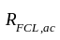
To obtain the relation between and , ac and dc sides active power (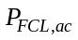 and 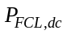, respectively) must be considered equal. So:

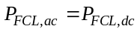 (13)
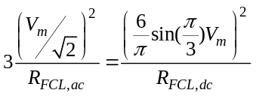 (14)

Where, 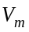 is the peak of isolation transformer secondary voltage.
As result:

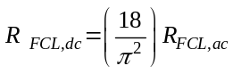 (15)
Then:

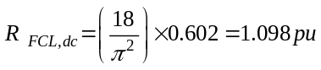 (16)

It should be noticed that is equal to 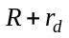. Since is negligible respect to , is equal to , approximately.
- Simulation Results
The power circuit topology of Fig. 2 is used for simulation in fault condition. The simulation parameters are as follows:
Generator data:

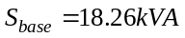, 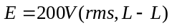, 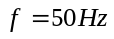
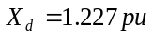, 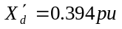

And number of generator poles is 4.
System parameters:

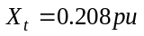, 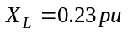
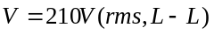

FCL parameters:

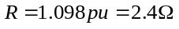, 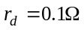, 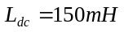,
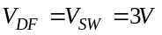

Fault occurs at 6 (sec) and continues until 0.16 (sec) (8 cycles of power frequency).
As fault occurs, without using FCL, the fault current increases extremely and generator becomes unstable. But, by using proposed NSFCL, fault current is limited properly and generator became stable.
Fig. 6 shows the generator current with and without using proposed FCL.
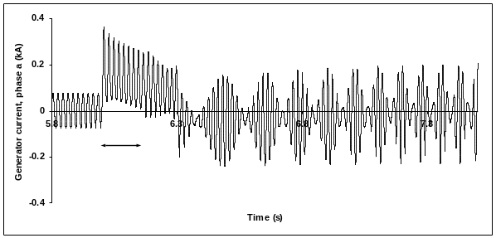
(a)
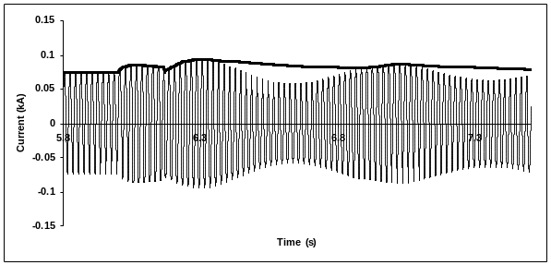
(b)
Figure 6. (a) Generator current without NSFCL (b) Generator current with NSFCL (──) and dc reactor current (▬▬)
Fig. 7 shows the rotor speed response of generator after fault. Note that the NSFCL with an optimal value of 1.098p.u. has the best damping performance for oscillations when compared to that by the NSFCL with other values such as 0.5, 2 (p.u.) and the case without NSFCL.
Consumed power of NSFCL resistor () for three values of (0.5, 1.098 and 2(p.u.)) are shown in Fig. 8. As it can be seen, for optimum value of , consumed power of NSFCL resistor is near to pre-fault electrical power. In other words, accelerating area and consequently, rotor speed oscillation are minimized.
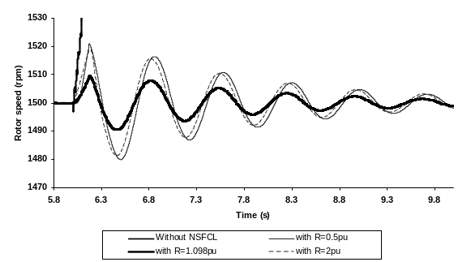
Figure 7. Rotor speed
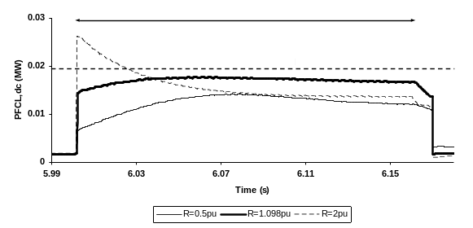
Figure 8. Consumed power of NSFCL resistor
- Conclusions
This paper presented a new power circuit topology for improvement of transient stability by using non-superconducting FCL. Analytic analyses are performed for pre-fault and during fault conditions and optimal resistance of NSFCL that leads to the best stability improvement is calculated. Setting the optimal value for resistance of FCL in this topology is simpler respect to superconductor types. Simulations are performed in EMTDC/PSCAD for several values of resistor to show the accuracy of analysis. So, this NSFCL with optimum resistor can improve transient stability of system, as well as good fault current limitation. In addition, there is no need to high technology and costs of superconductor in proposed FCL.
References
[1] Lin Ye, LiangZhen Lin, and Klaus-Peter Juengst, “Application Studies of Superconducting Fault Current Limiters in Electric Power Systems,” IEEE Trans on Applied Superconductivity, vol. 12, no. 1, March 2002.
[2] Mehrdad Tarafdar Hagh, Mehdi Abapour, “Nonsuperconducting Fault Current Limiter With Controlling the Magnitudes of Fault Currents,” IEEE Trans. On Power Electronics, vol. 24, no. 3, March 2009.
[3] M. M. R. Ahmed, G. A. putrus, L. Ran, “Power Quality Improvement Using Solid State Fault Current limiter,” IEEE, Transmission and Distribution Conference, Asia Pacific, vol. 2, pp. 1059-1064, Oct. 2002.
[4] M. Tarafdar Hagh and M. Abapour, “DC reactor type transformer inrush current limiter,” IET Electr. Power, vol. 1, no. 5, pp. 808–814, Appl., 2007.
[5] M. Tsuda, Y. Wlitani, K. Tsuji, K. Kakihana, “Application of Resistor Based Superconducting Fault Current Limiter to Enhancement of Power System Transient Stability,” IEEE Trans. On Applied superconductivity, vol. 11, no. 1, March 2001.
[6] Hiroyuki Hatta, Shinichi Muroya, Tanzo Nitta, Yasuyuki Shirai, and Masaumi Taguchi, “Experimental Study on Limiting Operation of Superconducting Fault Current Limiter in Double Circuit Transmission Line Model System,” IEEE Trans on Applied Superconductivity, vol. 12, no. 1, March 2002.
[7] Y. Shirai, , K. Furushiba, Y. Shouno, M. Shiotsu, and T. Nitta, “Improvement of Power System Stability by Use of Superconducting Fault Current Limiter With ZnO Device and Resistor in Parallel,” IEEE Trans on Applied Superconductivity, vol. 18, no. 2, June 2008.
[8] Byung Chul Sung,, Dong Keun Park, Jung-Wook Park, and Tae Kuk Ko, “Study on a Series Resistive SFCL to Improve Power System Transient Stability: Modeling, Simulation, and Experimental Verification,” IEEE Trans on Industrial Electronics , vol. 56, no. 7, July 2009.
[9] H. Hooshyar, M. Savaghebi, “RSFCL Optimum Shunt Resistance Determination to Enhance Power System Transient Stability,” Universities Power Engineering Conference, Sept. 2008.
[10] Y. Ye, L. Xiao, H. Wang, and Z. Zhang, “Research on resistor type superconducting fault current limiter in power system,” in Proc. IEEE/PES Transmiss. Distrib. Conf. Exhib.: Asia Pacific, 2005.
[11] M. Tsuda, Y. Mitani, K. Tsuji, and K. Kakihana, “Application of resistor based superconducting fault current limiter to enhancement of power system transient stability,” IEEE Trans. Appl. Supercond., vol. 11, no. 1, pp. 2122–2125, March 2001.
[12] Mehrdad Tarafdar Hagh, Mehdi Abapour, “Nonsuperconducting Fault Current Limiter With Controlling the Magnitudes of Fault Currents,” IEEE Trans. On Power Electronics, vol. 24, no. 3, March 2009

